

A Project

Report On

Tourism Management System

**By**

**Namburi Vijay**

**BCA**

**Batch:2020-5355**

**Center:** **Bangalore-TC/Palya**

Under the Guidance of,

**V. Jayanth**

**Technical Trainer**

**EduBridge**

(School of coding)

**Introduction:**

 The **tourism management system** allows the user of the **system** access all the details such as location, events, etc. ... The main purpose is to help **tourism** companies to manage customer and hotels etc. The **system** can also be used for both professional and business trips. The **importance** of **tourism** for every country in the world arises from the various benefits it offers to the host country. After all, **tourism** contributes to the country's economic growth and development by bringing valuable benefits to the locals as well as to businesses.

**Our Project Include Modules:**

* Admin Module
* Login Module
* Registration module

I have developed this Application in **Java, JSP, Servlets, and MySQL.** It’s a web-based projects so I have used **HTML, CSS**.

Tourism management system is a good application for booking tickets to travel. In old days we don’t have any technology so we should go to the nearest retailer but now a days we no need to go anywhere we can book anything at the same place.

**Admin:**

Admin can add packages he/she want. While adding the package he should give the package name, place, number of days, cost. If he/she add same package name with same place the package will not be added if admin add same package name but different place then it will be added.

Admin should add hotels first so that he/she can add rooms later with respective to the hotel name. In room admin should add type and size of the room and finally cost of the room.

Admin can also add the food by selecting which type of food he want to be added.

Finally he/ she can also add the transport like which type of vehicle user may need.

Admin can update/delete the package, room, food and transport which was added by him/her.

He/she can add the percentage of discount for any package which was selected by user as his/her 1st package.

Admin can also update the discount program like changing the discount percentage or deleting the discount.

He/she can view all the payment details finally made by the users.

**Login:**

User should register to the site with all the required details. And then he/she can login to the site. User can also reset their password if they registered already.

User can search for the packages which were added by the admin. He/ she can view the packages with place in a table by selecting any package name displayed in the dropdown box.

User can book their food, transport and room only if they book any package in the site. If they don’t book any package then they cannot book any of the things listed above.

User can view different types of room and size of room by selecting the hotel name. Coming to food they can book any kind of food by selecting type of food they want. Similarly, they can book there transport by selecting the mean of transport they want to travel.

User can view there packages, food, room and transport they have booked and they can modify / cancel them according.

Finally, they can view their conformation page where they can see the total cost of the package that is sum of package cost, room cost, food cost and transport cost so that they can pay the total money.

In this payment they will get 10% discount for their first package and 30% discount for their 3rd package. In additional to the 10% for the 1st package they can get any additional discounts if available for the selected package which are added by admin.

**Software Requirements:**

**Front end:** Java/J2EE technologies (Servlet, JSP), HTML, CSS

**Back end**: MySQL workbench 6.2.4.12437 build 2426

**Middleware/Server:** Apache Tomcat v7.0. IDE: Eclipse IDE for Java EE Developers

**Browser:** Best result on Google Chrome

**Operating System:** Window 10.

# Data Dictionary

create Database `tourism`;

use `tourism`;

CREATE TABLE `bookfood` (

`type` varchar(45) NOT NULL,

`foodName` varchar(45) NOT NULL,

`foodCost` varchar(45) NOT NULL,

`quantity` varchar(45) NOT NULL,

`totalCost` int(45) NOT NULL,

`email` varchar(45) NOT NULL,

`packagename` varchar(45) NOT NULL,

`place` varchar(45) NOT NULL

) ENGINE=MyISAM DEFAULT CHARSET=latin1;

INSERT INTO `bookfood` (`type`, `foodName`, `foodCost`, `quantity`, `totalCost`, `email`, `packagename`, `place`) VALUES

('Non-Veg', 'Butter Chicken', '15', '350', 45, 'luffy', 'green building', 'missori'),

('Veg', 'Biryani', '15', '300', 45, 'luffy', 'green building', 'missori'),

('Non-Veg', 'Chicken Biryani', '10', '350', 10, 'luffy', 'green building', 'missori');

CREATE TABLE `bookpackage` (

`id` int(3) NOT NULL,

`packagename` varchar(45) NOT NULL,

`place` varchar(45) NOT NULL,

`packageCost` varchar(45) NOT NULL,

`days` varchar(45) NOT NULL,

`noofPersons` varchar(45) NOT NULL,

`totalcost` int(45) NOT NULL,

`email` varchar(45) NOT NULL

) ENGINE=MyISAM DEFAULT CHARSET=latin1;

INSERT INTO `bookpackage` (`id`, `packagename`, `place`, `packageCost`, `days`, `noofPersons`, `totalcost`, `email`) VALUES

(1, 'green building', 'washington', '30', '1', '1', 30, 'nikesh@gmail.com'),

(2, 'Snow Time', 'NC', '20', '2', '1', 20, 'nikesh@gmail.com'),

(1, 'waterfall', 'nc', '20', '1', '1', 20, 'sai@gmail.com'),

(2, 'Snow Time', 'NC', '20', '2', '1', 20, 'sai@gmail.com'),

(1, 'Snow Time', 'NC', '20', '2', '10', 200, 'nikesh2804@gmail.com'),

(3, 'green building', 'missori', '30', '2', '1', 30, 'nikesh@gmail.com'),

(1, 'green building', 'missori', '30', '2', '2', 60, 'luffy');

CREATE TABLE `bookroom` (

`hotelName` varchar(45) NOT NULL,

`roomType` varchar(45) NOT NULL,

`roomSize` varchar(45) NOT NULL,

`roomCost` int(45) NOT NULL,

`roomDate` varchar(45) NOT NULL,

`email` varchar(45) NOT NULL,

`packagename` varchar(45) NOT NULL,

`place` varchar(45) NOT NULL

) ENGINE=MyISAM DEFAULT CHARSET=latin1;

INSERT INTO `bookroom` (`hotelName`, `roomType`, `roomSize`, `roomCost`, `roomDate`, `email`, `packagename`, `place`) VALUES

('swagath', 'AC', 'Single', 100, '2017-02-23', 'luffy', 'green building', 'missori'),

('Taj', 'AC', 'Double', 300, '2017-02-15', 'nikesh2804@gmail.com', 'Snow Time', 'NC'),

('Taj Lake Palace', 'AC', 'Double', 300, '2017-02-16', 'vijay@gmail.com', 'Snow Time', 'NC'),

('Taj', 'AC', 'Double', 300, '2017-02-16', 'nikesh2804@gmail.com', 'Snow Time', 'NC');

CREATE TABLE `booktransport` (

`transportType` varchar(45) NOT NULL,

`vehicleType` varchar(45) NOT NULL,

`vehicleName` varchar(45) NOT NULL,

`vehicleCost` int(45) NOT NULL,

`vehicleDate` varchar(45) NOT NULL,

`email` varchar(45) NOT NULL,

`packagename` varchar(45) NOT NULL,

`place` varchar(45) NOT NULL

) ENGINE=MyISAM DEFAULT CHARSET=latin1;

INSERT INTO `booktransport` (`transportType`, `vehicleType`, `vehicleName`, `vehicleCost`, `vehicleDate`, `email`, `packagename`, `place`) VALUES

('Car', 'AC', 'sonata sport', 300, '2017-02-17', 'nikesh2804@gmail.com', 'Snow Time', 'NC'),

('bus', 'AC', 'sonata sport', 300, '2017-02-17', 'nikesh2804@gmail.com', 'Snow Time', 'NC'),

('Car', 'AC', 'sonata sport', 300, '2017-02-22', 'luffy', 'green building', 'missori');

CREATE TABLE `discount` (

`packagename` varchar(45) NOT NULL,

`discount` varchar(45) NOT NULL

) ENGINE=MyISAM DEFAULT CHARSET=latin1;

INSERT INTO `discount` (`packagename`, `discount`) VALUES

('green building', '20'),

('waterfall', '10');

CREATE TABLE `food` (

`foodtype` varchar(45) NOT NULL,

`foodname` varchar(45) NOT NULL,

`foodcost` varchar(45) NOT NULL

) ENGINE=MyISAM DEFAULT CHARSET=latin1;

INSERT INTO `food` (`foodtype`, `foodname`, `foodcost`) VALUES

('Non-Veg', 'Chicken Biryani', '350'),

('Non-Veg', 'Butter Chicken', '350'),

('Veg', 'Biryani', '300'),

('Veg', 'Gobi', '250');

CREATE TABLE `hotel` (

`hotelName` varchar(45) NOT NULL

) ENGINE=MyISAM DEFAULT CHARSET=latin1;

INSERT INTO `hotel` (`hotelName`) VALUES

('swagath'),

('The Leela Palace'),

('Taj Lake Palace'),

('taj krishna');

CREATE TABLE `package` (

`id` int(4) NOT NULL,

`packagename` varchar(45) NOT NULL,

`place` varchar(45) NOT NULL,

`cost` varchar(45) NOT NULL,

`days` varchar(45) NOT NULL

) ENGINE=MyISAM DEFAULT CHARSET=latin1;

INSERT INTO `package` (`id`, `packagename`, `place`, `cost`, `days`) VALUES

(4, 'Snow Time', 'NC', '2500', '2'),

(5, 'waterfall', 'nc', '3500', '1'),

(7, 'green building', 'washington', '3000', '1'),

(8, 'green building', 'missori', '3500', '2');

CREATE TABLE `payment` (

`packagename` varchar(45) NOT NULL,

`place` varchar(45) NOT NULL,

`cost` varchar(45) NOT NULL,

`email` varchar(45) NOT NULL,

`cardName` varchar(45) NOT NULL,

`cardNumber` varchar(45) NOT NULL,

`cvv` varchar(45) NOT NULL

) ENGINE=MyISAM DEFAULT CHARSET=latin1;

INSERT INTO `payment` (`packagename`, `place`, `cost`, `email`, `cardName`, `cardNumber`, `cvv`) VALUES

('green building', 'washington', '27', 'nikesh@gmail.com', 'nikesh', '1234567891523654', '456');

CREATE TABLE `register` (

`name` varchar(45) NOT NULL,

`email` varchar(45) NOT NULL,

`password` varchar(45) NOT NULL,

`mobile` varchar(45) NOT NULL

) ENGINE=MyISAM DEFAULT CHARSET=latin1;

INSERT INTO `register` (`name`, `email`, `password`, `mobile`) VALUES

('nikesh', 'nikesh@gmail.com', 'sai', '1234567890'),

('sai', 'sai@gmail.com', 'sai', '7894561230'),

('nikesh', 'nikesh2804@gmail.com', '8121343348', '8121343348'),

('luffy', 'luffy', 'luffy', '8794561230'),

('vijay', 'vijay@gmail.com', '12345', '8794561230');

CREATE TABLE `room` (

`hotelName` varchar(45) NOT NULL,

`roomType` varchar(45) NOT NULL,

`roomSize` varchar(45) NOT NULL,

`roomCost` varchar(45) NOT NULL

) ENGINE=MyISAM DEFAULT CHARSET=latin1;

INSERT INTO `room` (`hotelName`, `roomType`, `roomSize`, `roomCost`) VALUES

('swagath', 'AC', 'Single', '100'),

('swagath', 'AC', 'Double', '1000'),

('The Leela Palace', 'Non-AC', 'Single', '2500'),

('The Leela Palace', 'AC', 'Double', '3500'),

('Taj Lake Palace', 'AC', 'Double', '3500'),

('Taj Lake Palace', 'Non-AC', 'Single', '3000'),

('taj krishna', 'Non-AC', 'Single', '1000'),

('taj krishna', 'AC', 'Double', '3500');

CREATE TABLE `transport` (

`transportType` varchar(45) NOT NULL,

`vehicleType` varchar(45) NOT NULL,

`vehicleName` varchar(45) NOT NULL,

`vehicleCost` varchar(45) NOT NULL

) ENGINE=MyISAM DEFAULT CHARSET=latin1;

INSERT INTO `transport` (`transportType`, `vehicleType`, `vehicleName`, `vehicleCost`) VALUES

('Car', 'AC', 'sonata sport', '3000'),

('Bus', 'AC', 'Bus', '5000'),

('Mini-Bus', 'Non-AC', 'Mini-Bus', '3000'),

('Bus', 'Non-AC', 'Bus', '5000'),

('mini-van', 'Non-AC', 'mini-van', '4000'),

('Mini-Bus', 'AC', 'Mini-Bus', '8000');

ALTER TABLE `bookpackage`

ADD KEY `id` (`id`) USING BTREE;

ALTER TABLE `package`

ADD KEY `id` (`id`);

ALTER TABLE `bookpackage`

MODIFY `id` int(3) NOT NULL AUTO_INCREMENT, AUTO_INCREMENT=27;

ALTER TABLE `package`

MODIFY `id` int(4) NOT NULL AUTO_INCREMENT, AUTO_INCREMENT=12;

/*!40101 SET CHARACTER_SET_CLIENT=@OLD_CHARACTER_SET_CLIENT */;

/*!40101 SET CHARACTER_SET_RESULTS=@OLD_CHARACTER_SET_RESULTS */;

/*!40101 SET COLLATION_CONNECTION=@OLD_COLLATION_CONNECTION */;

# Screenshots:-

**Admin page:**

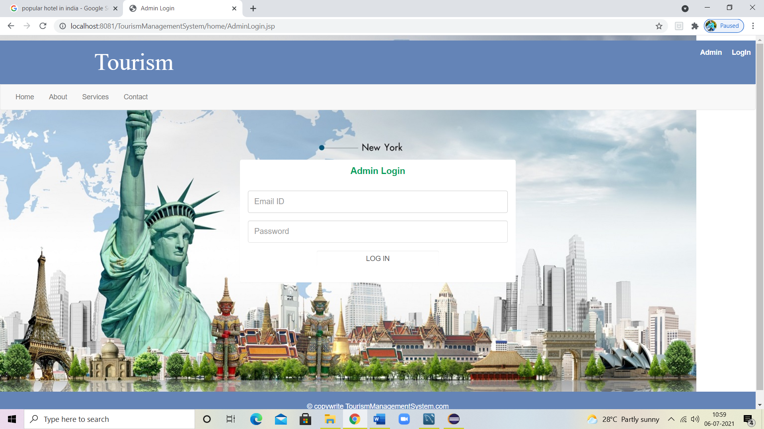

**Login With Admin Details:**

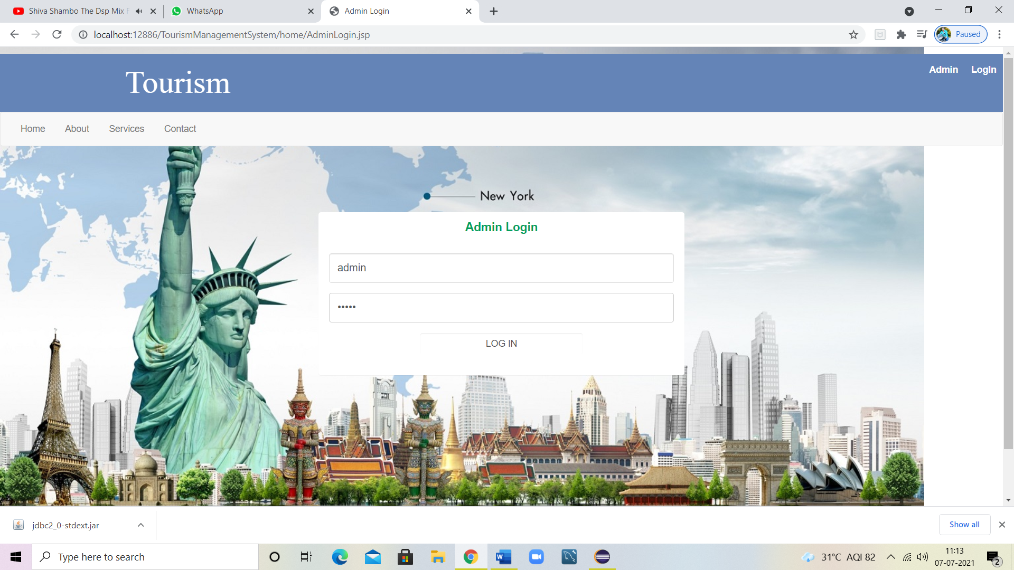

**Admin Welcome Page:**

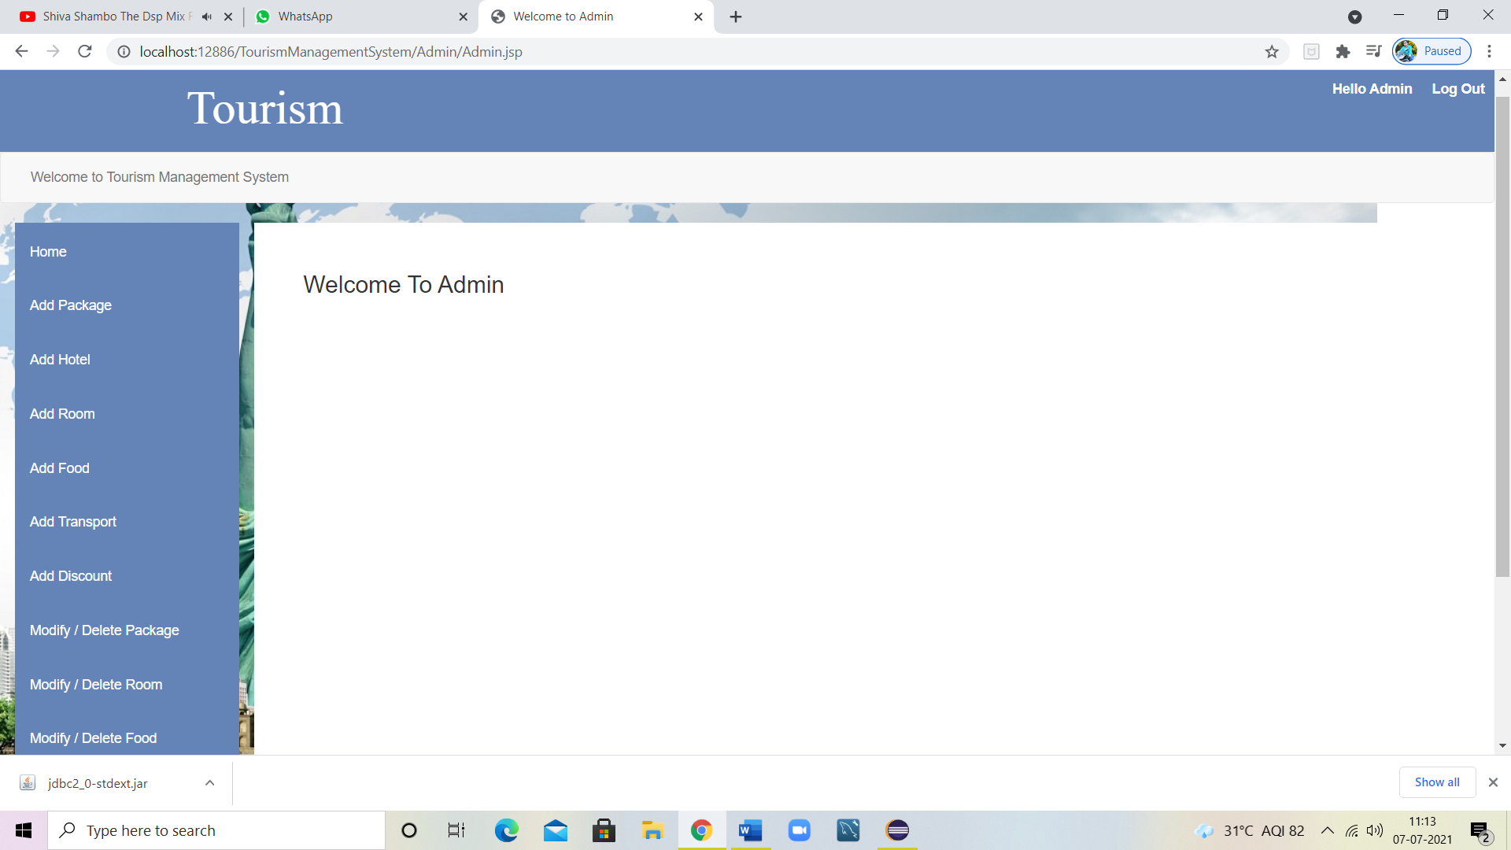

**Add Package:**

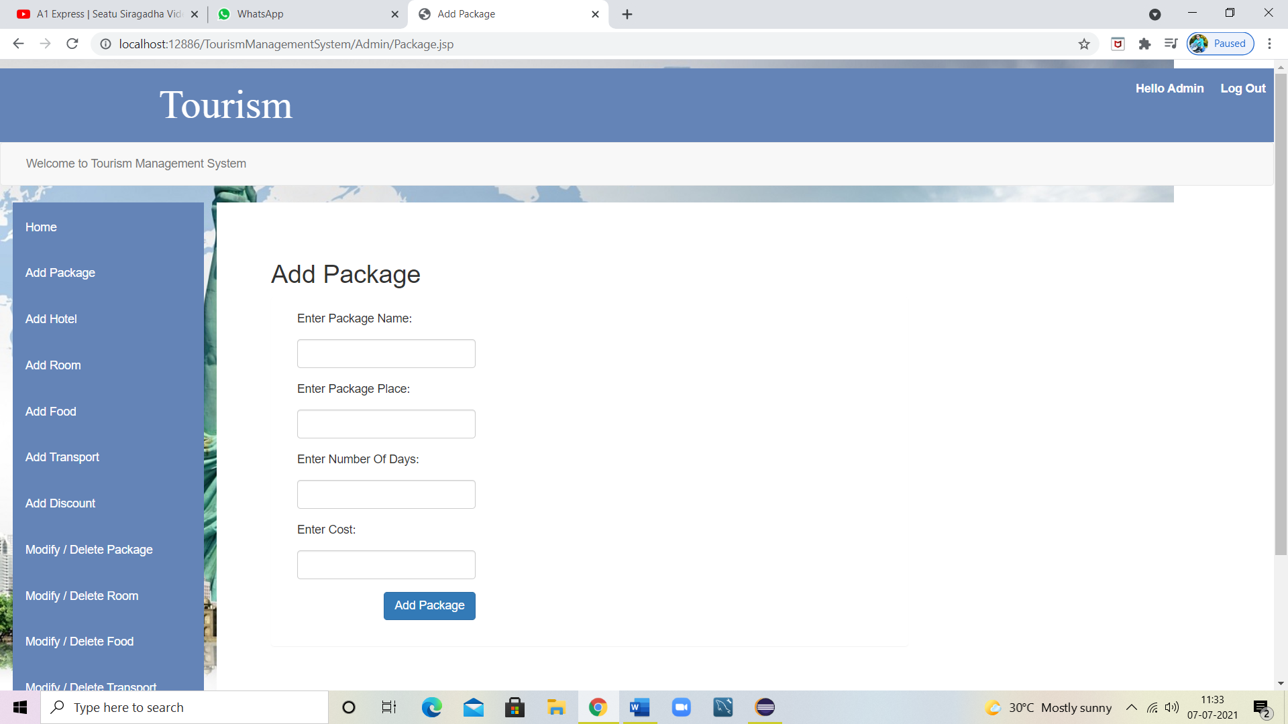

**Added Hotel:**

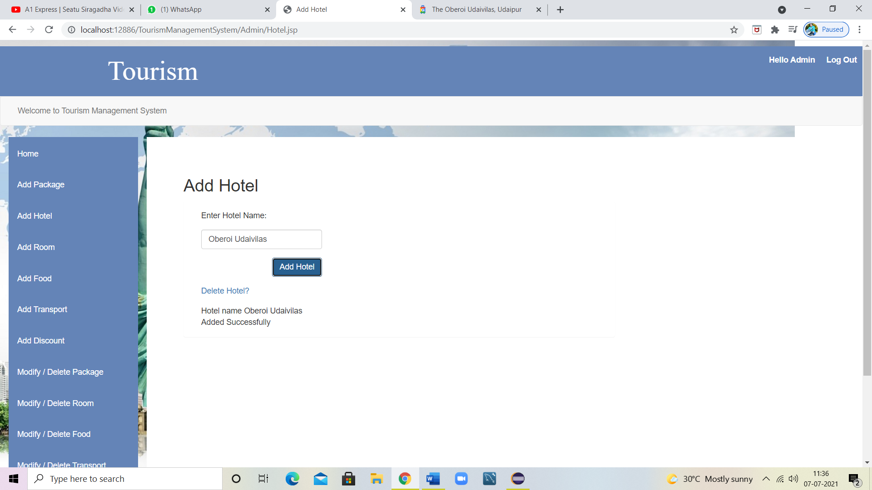

**Added Room:**

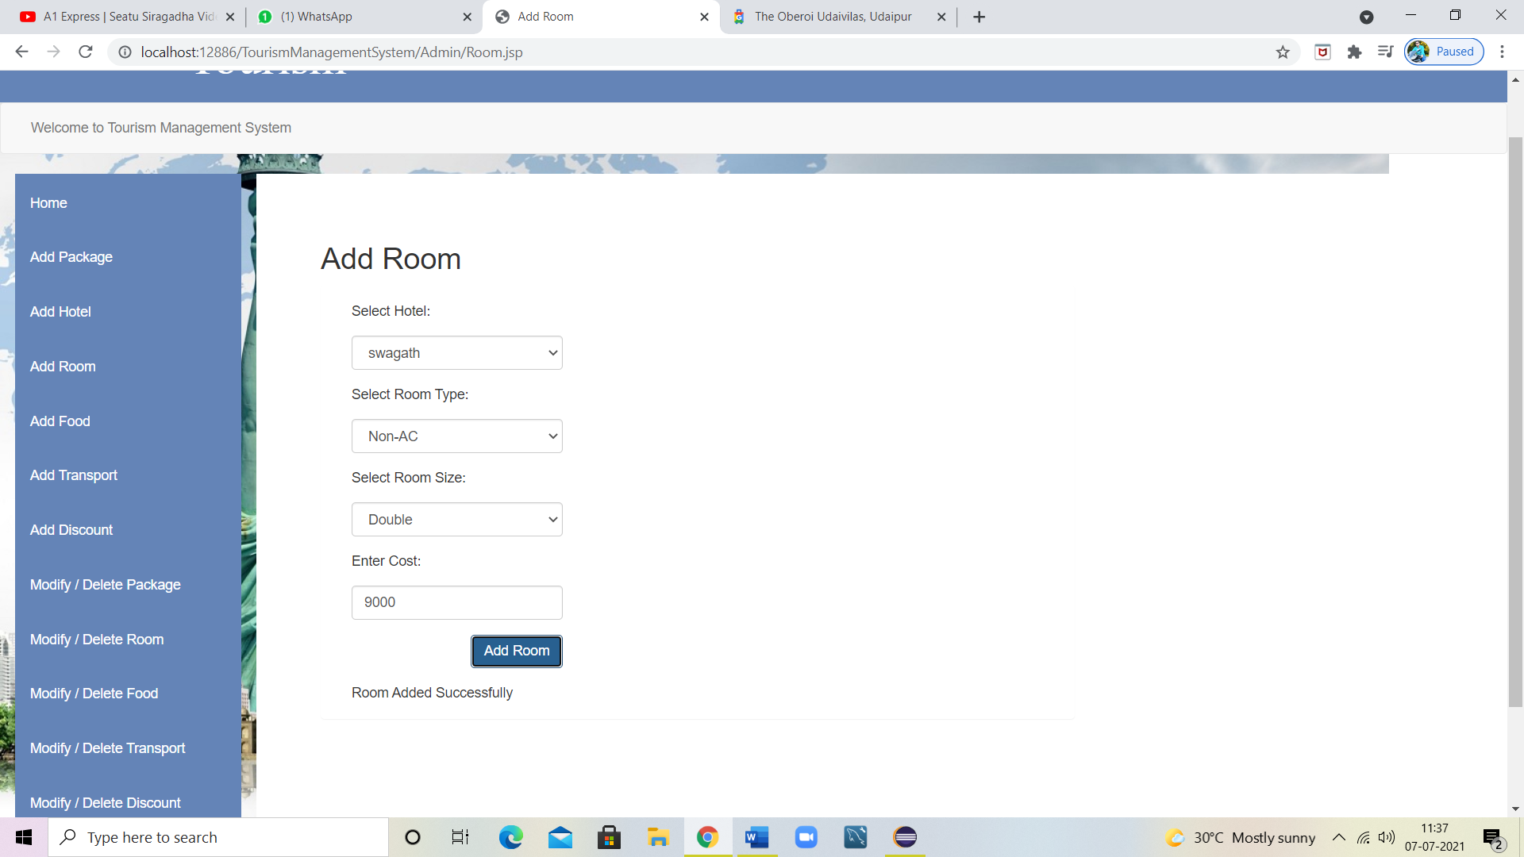

**Added Transport:**

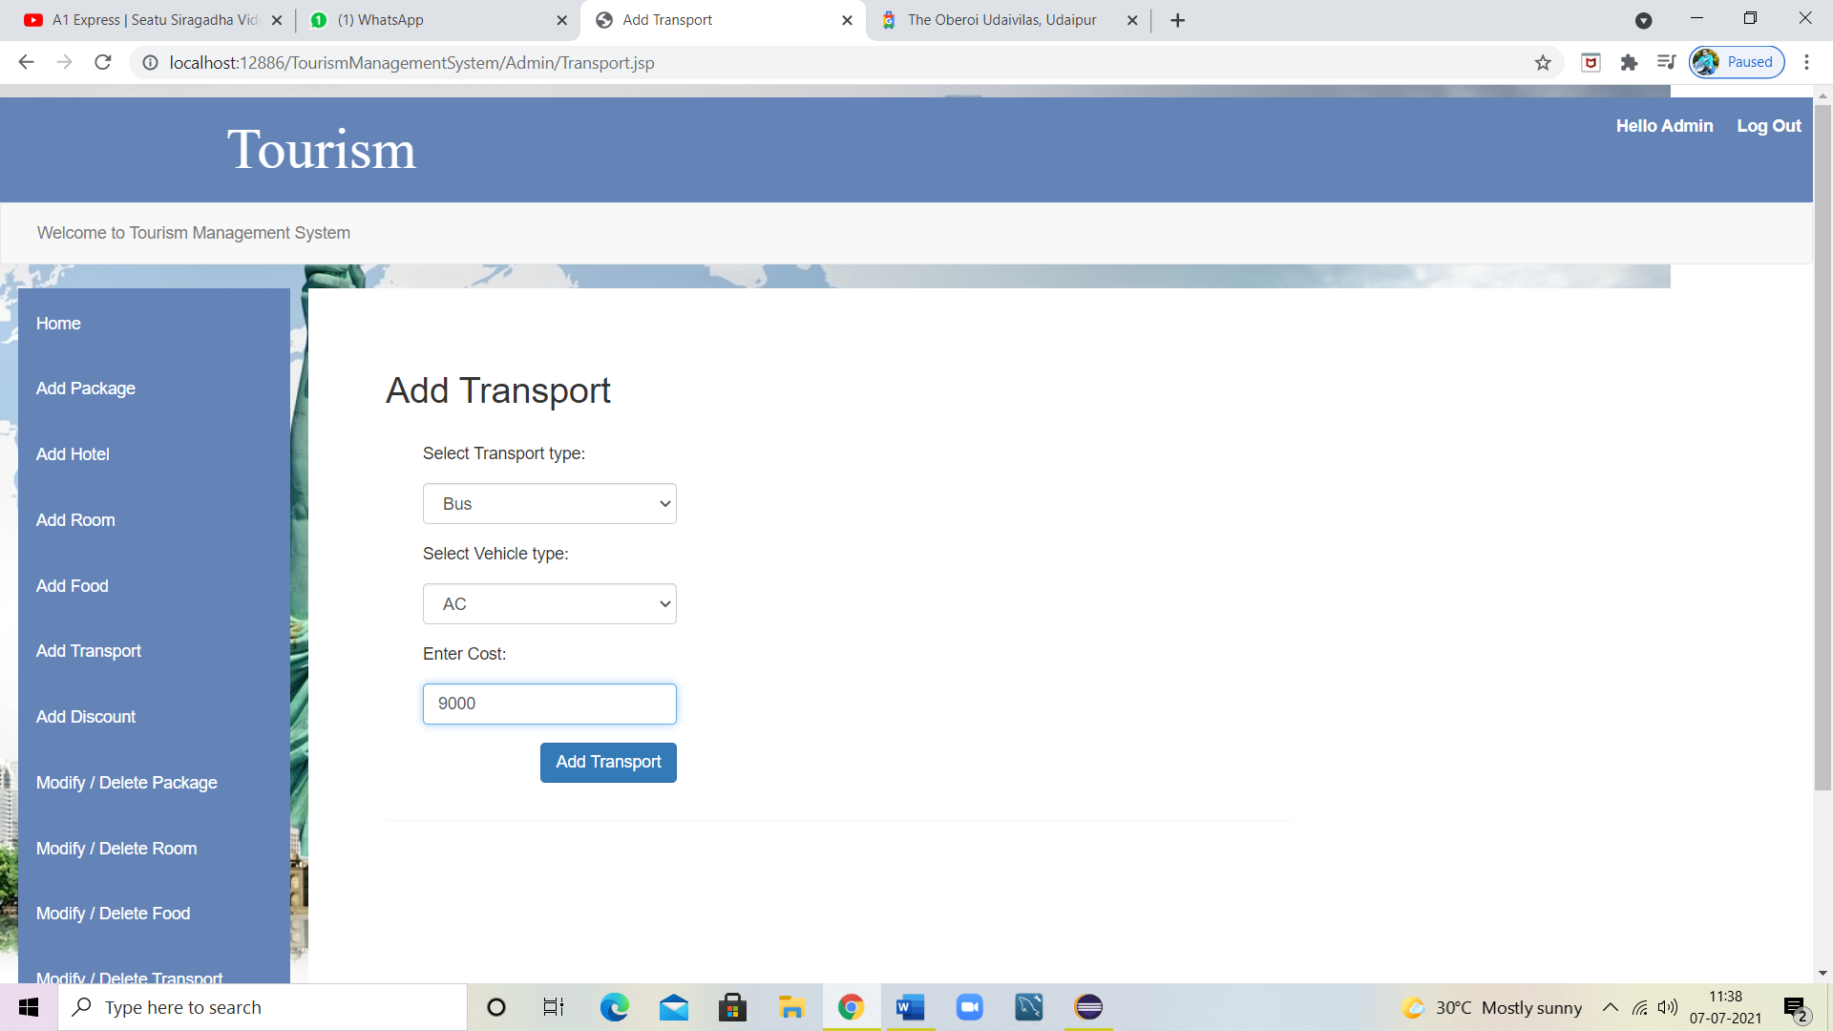

**Modify/Delete Package:**

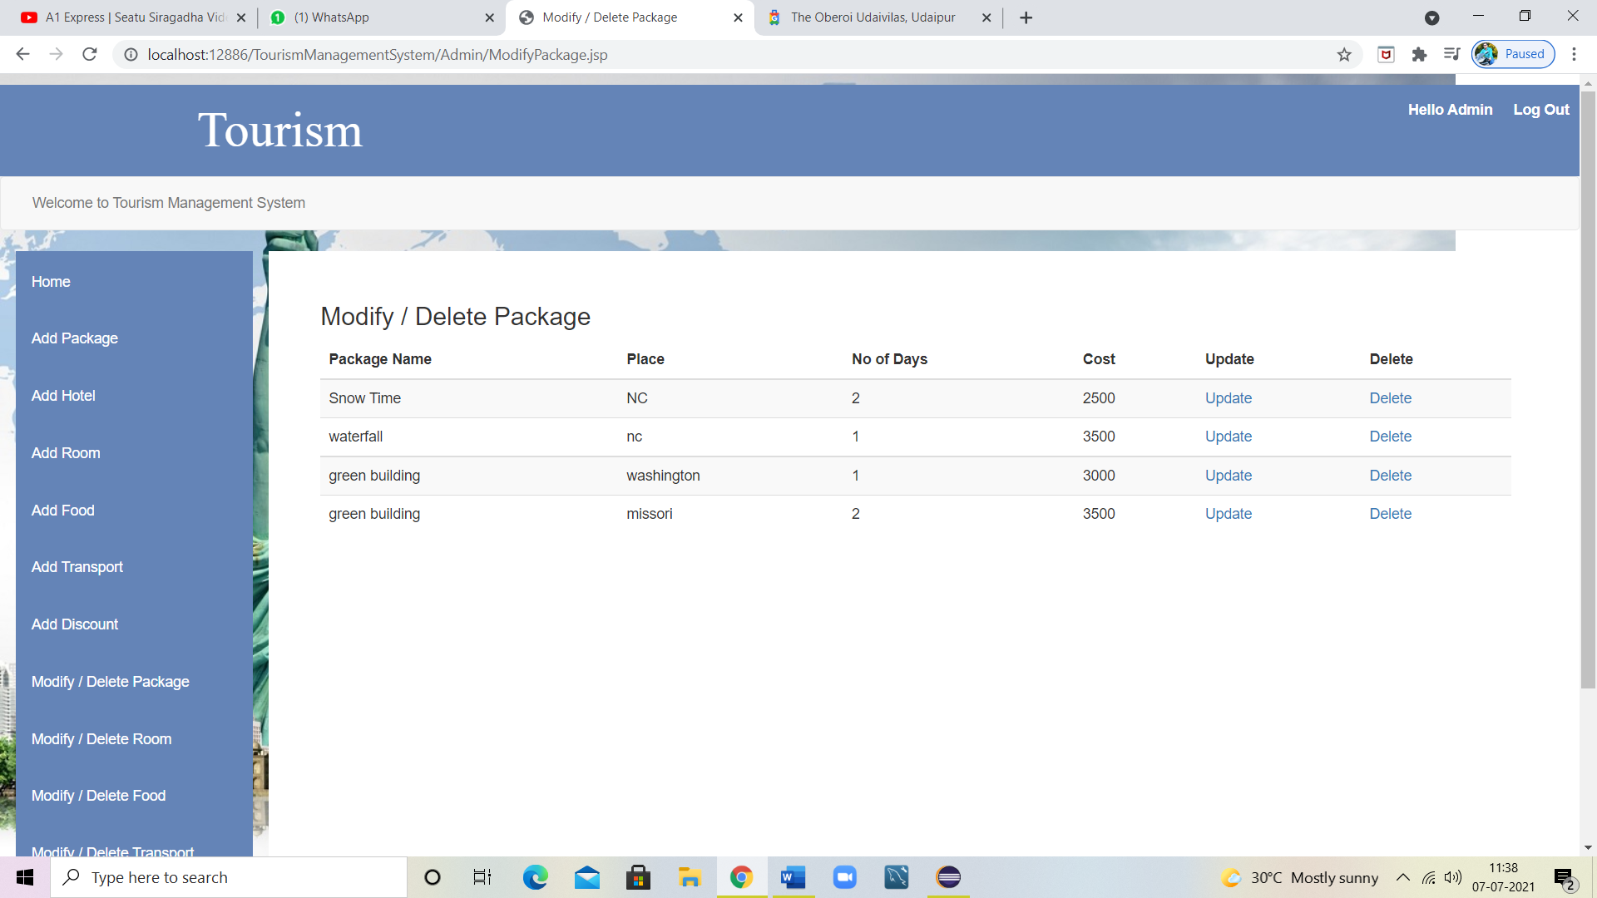

**Modify/Delete Room:**

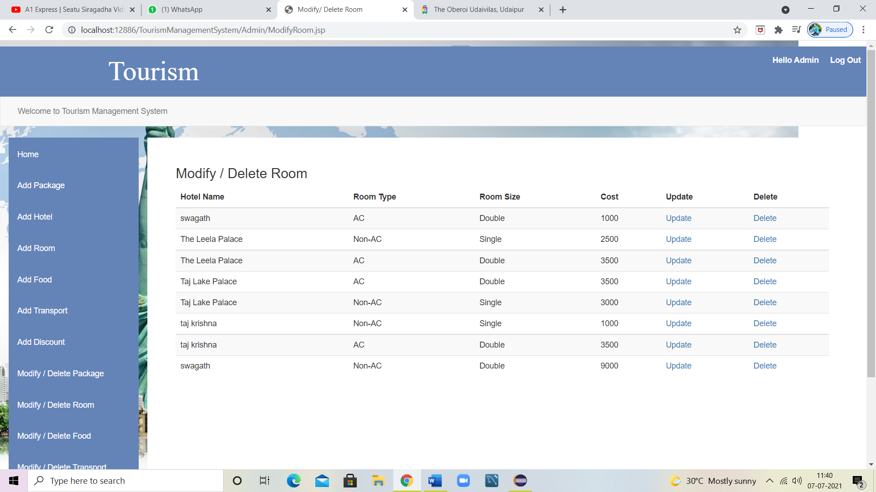

**Modify/Delete Food:**

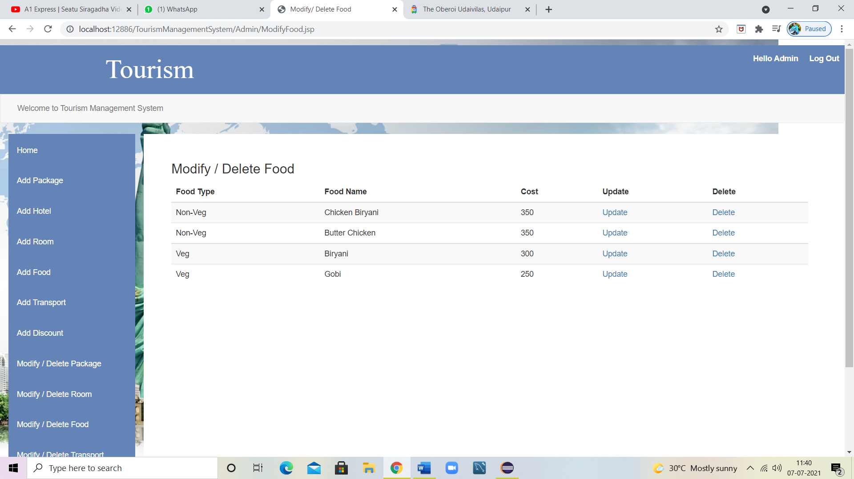

**Modify/Delete Transport:**

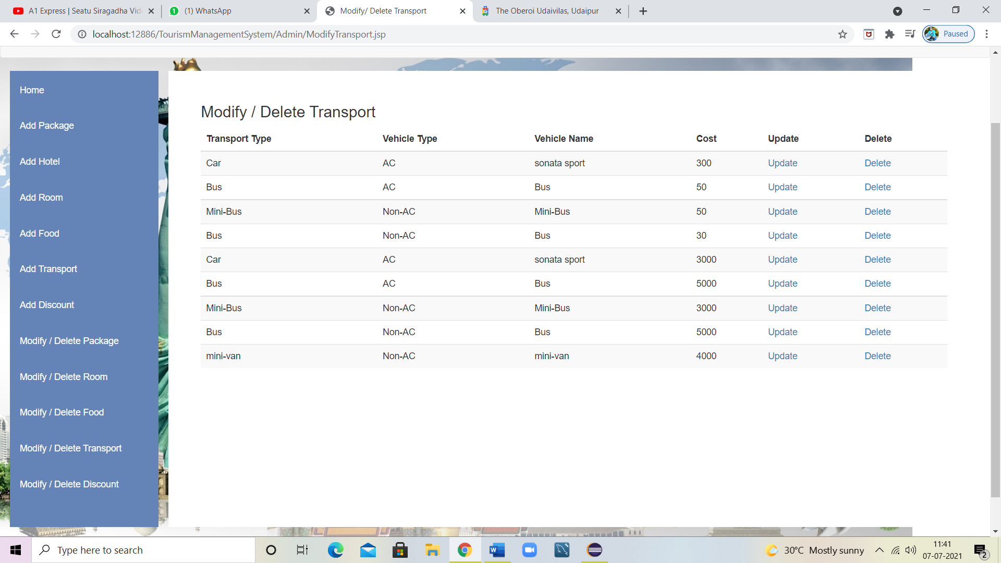

**Modify/Delete Discount:**

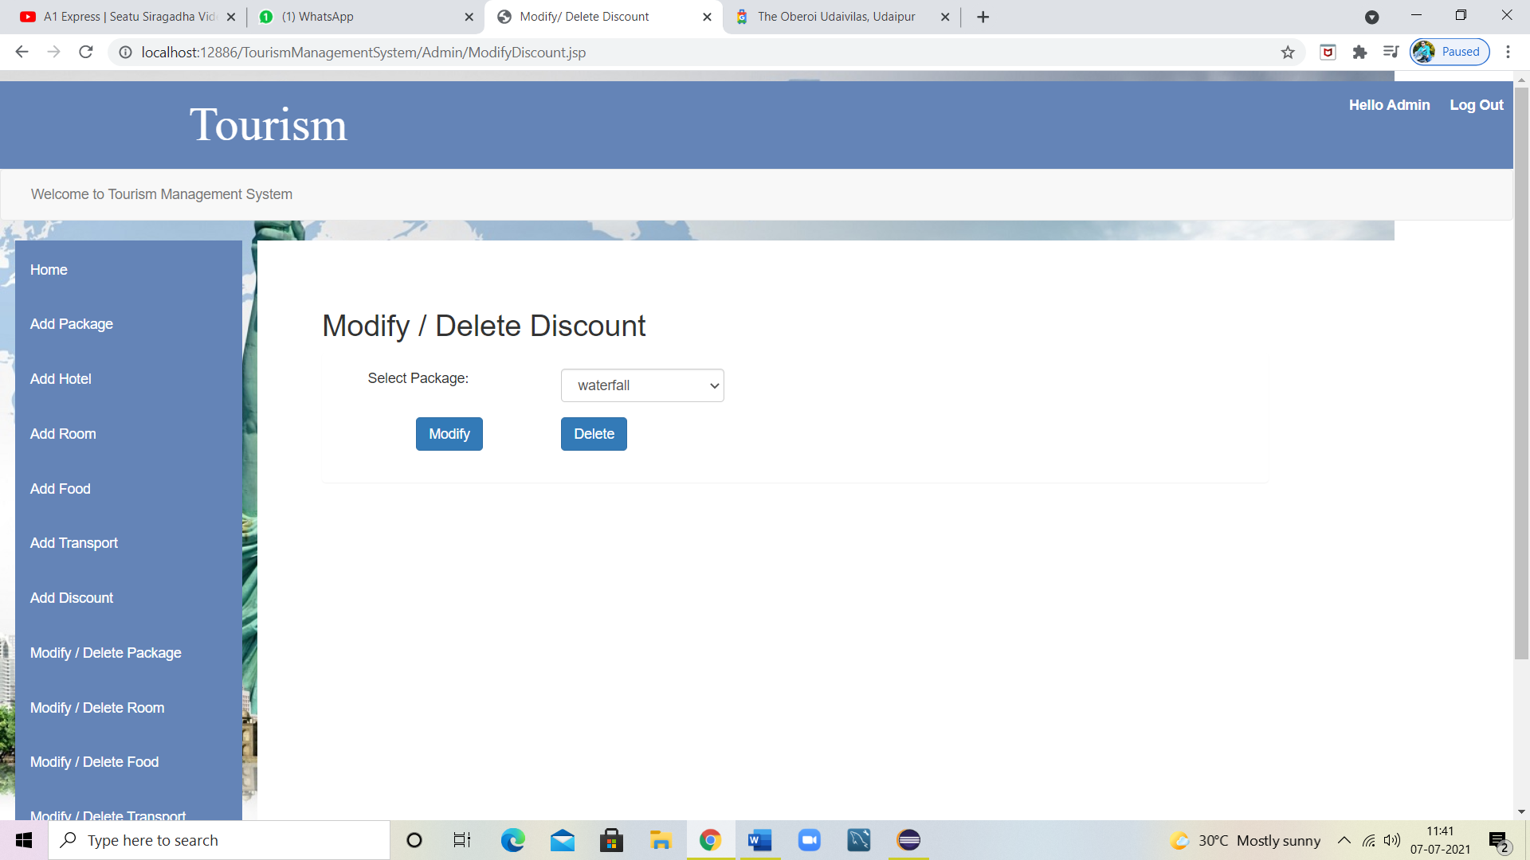

**Login page:**

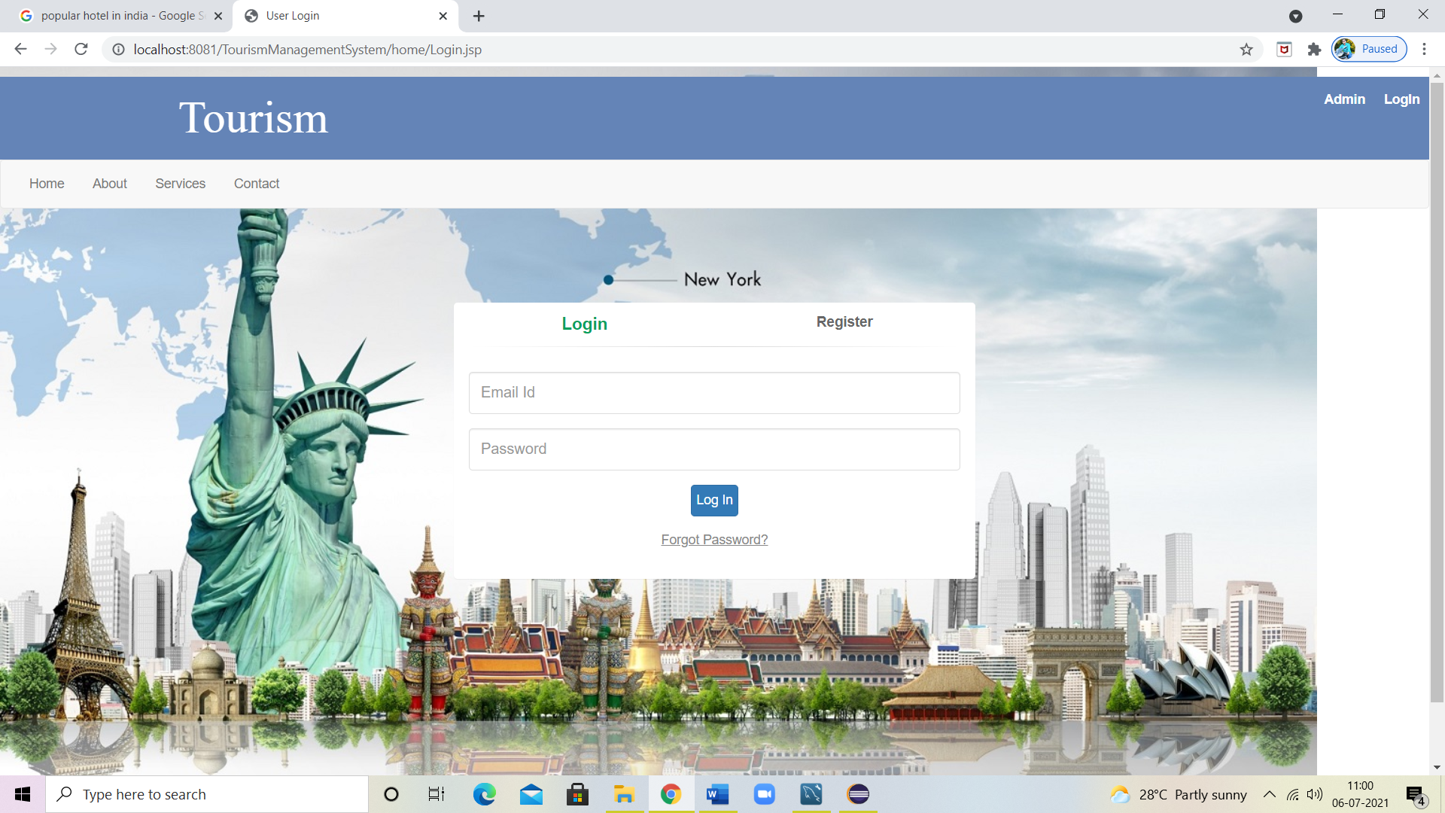

**Registering with data:**

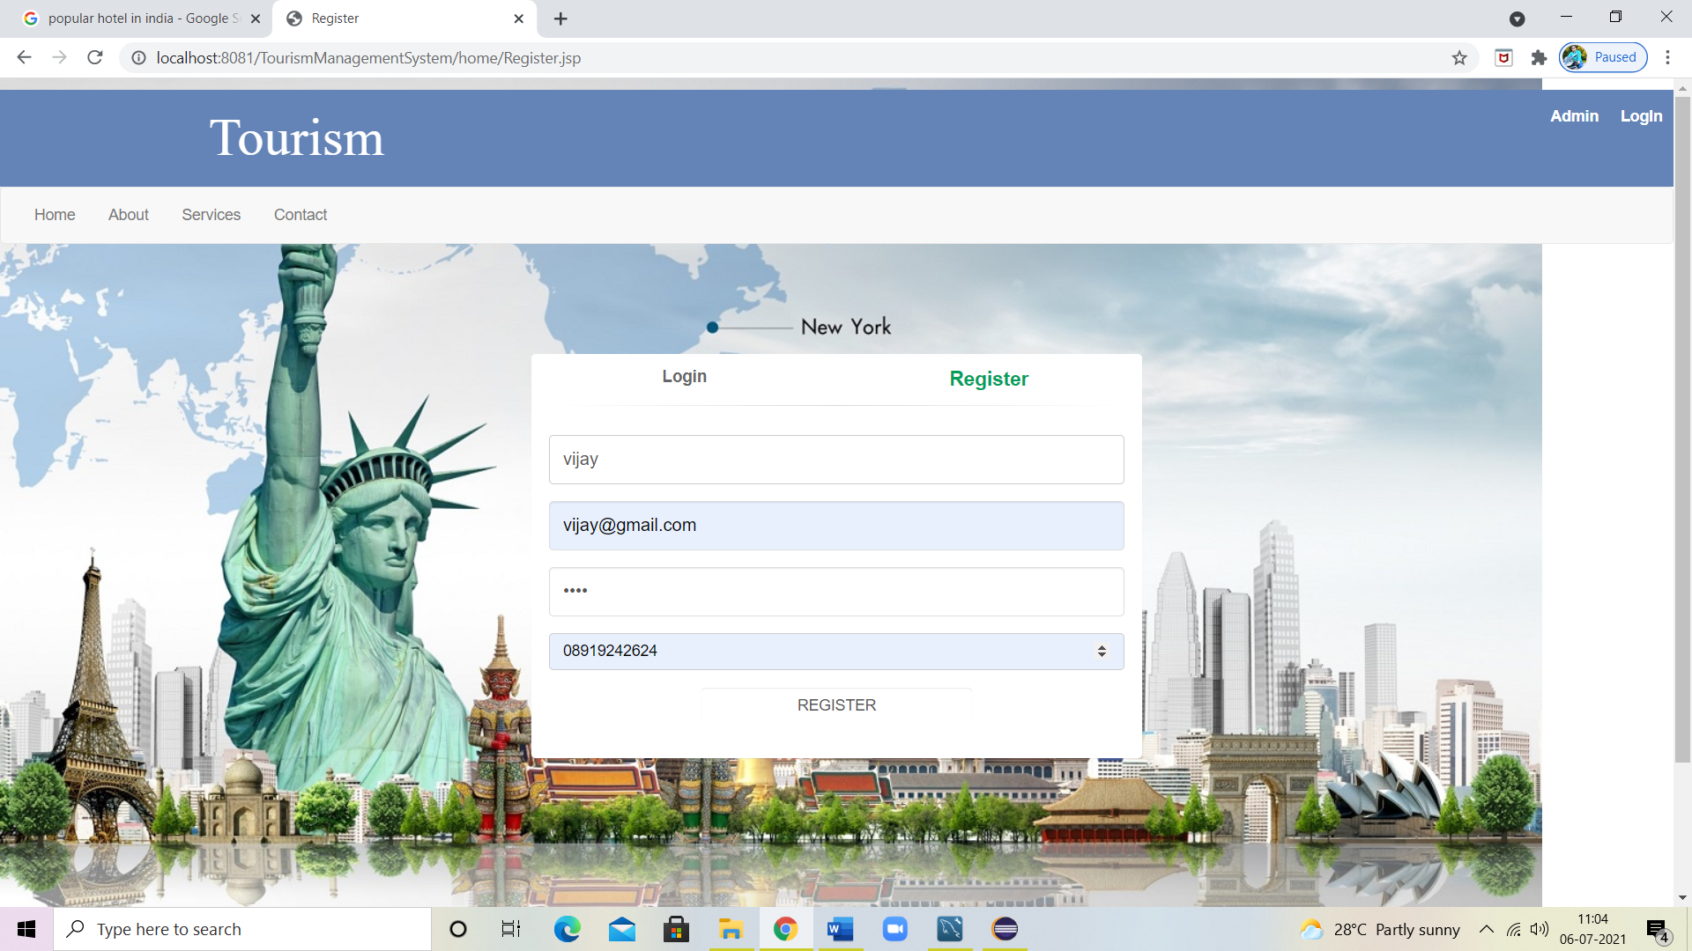

**Registration Successful done:**

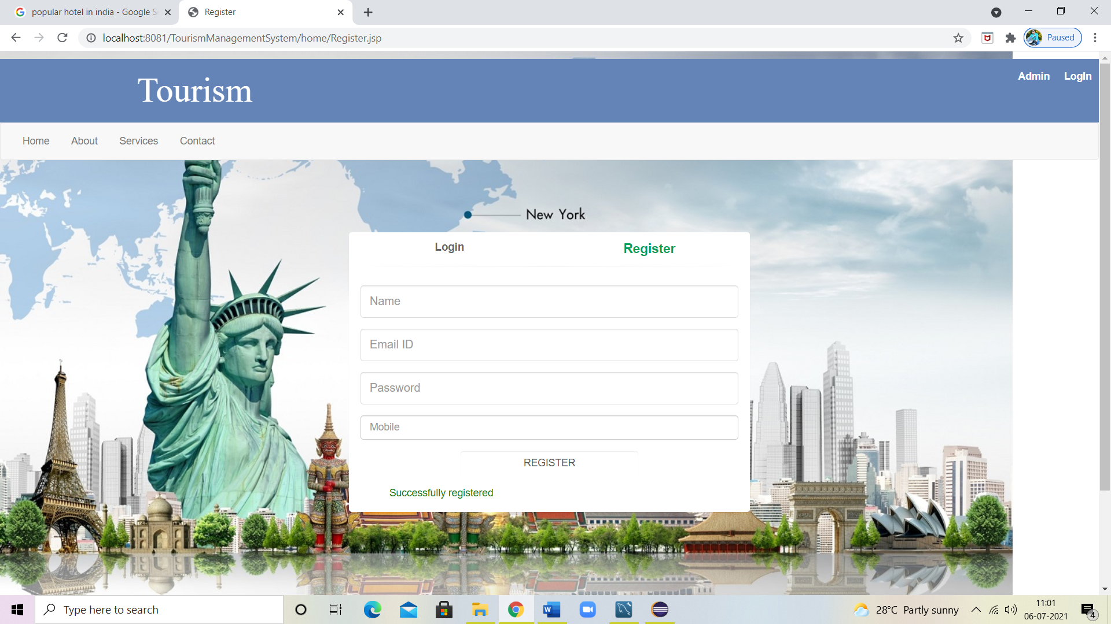

**Login With Registration Details:**

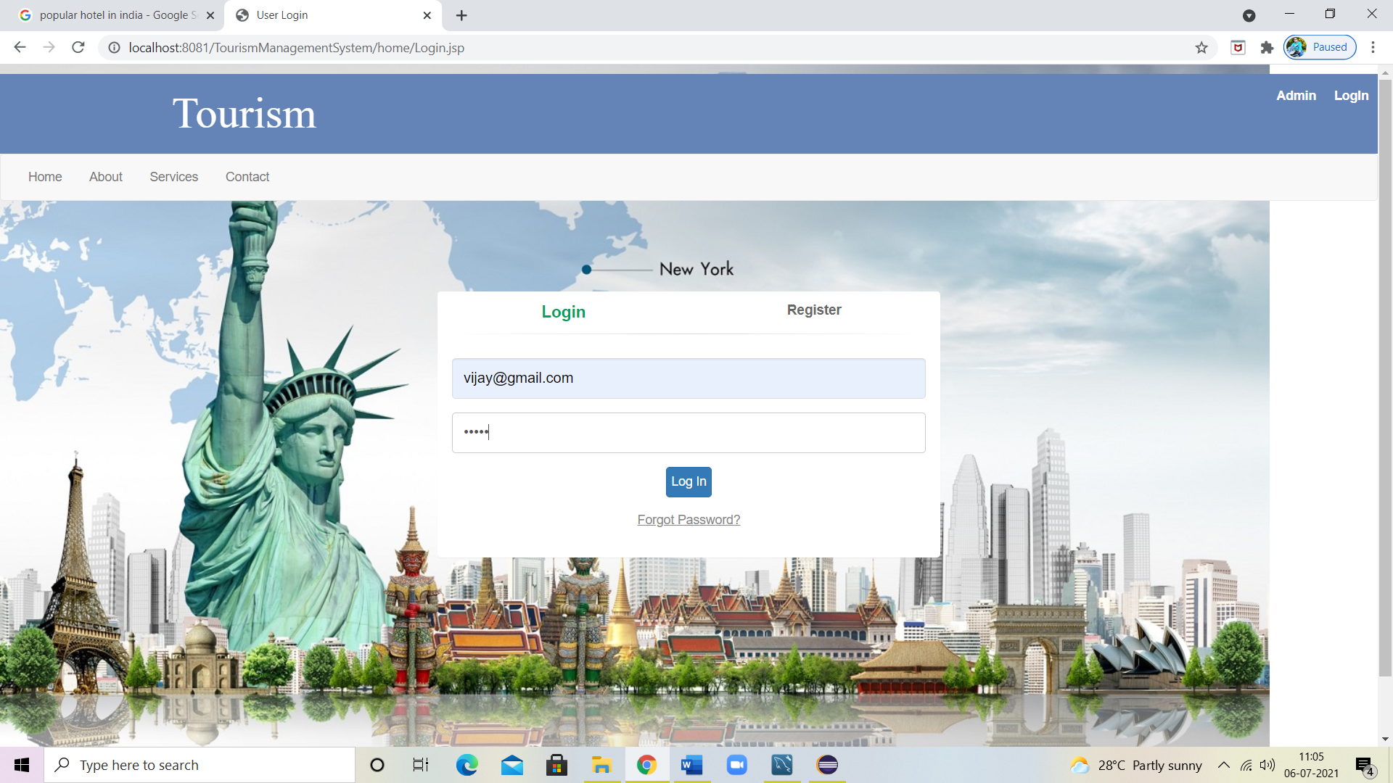

**Welcome Page:** 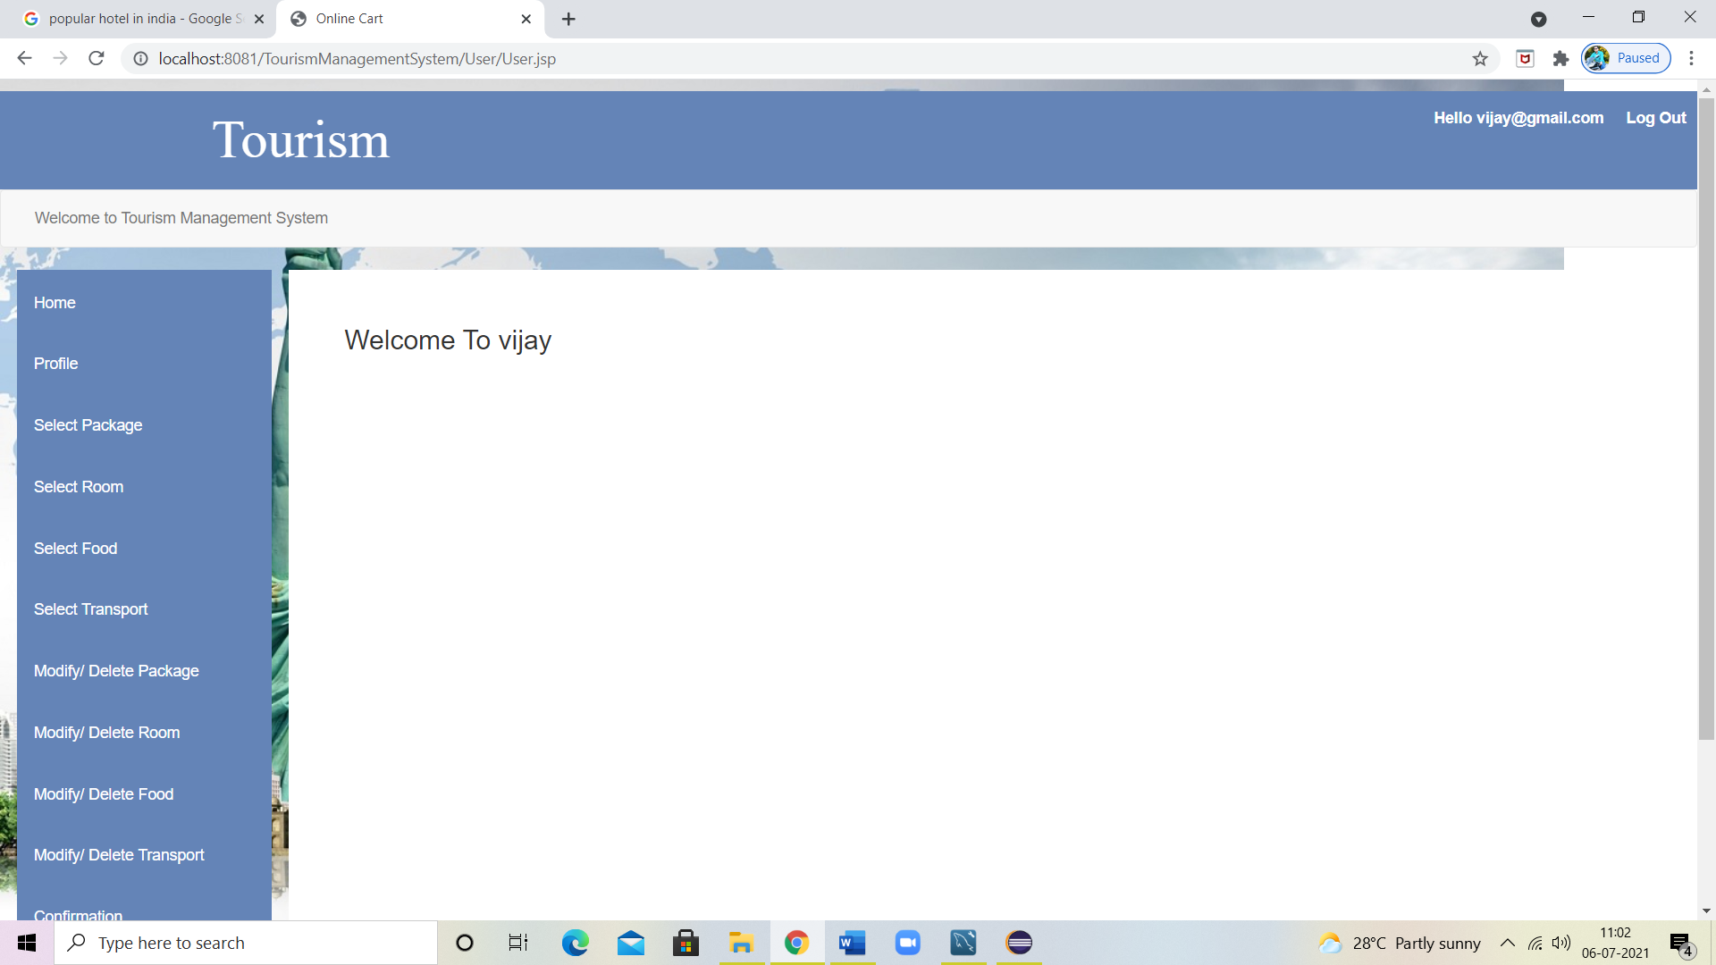

**Profile Page:**

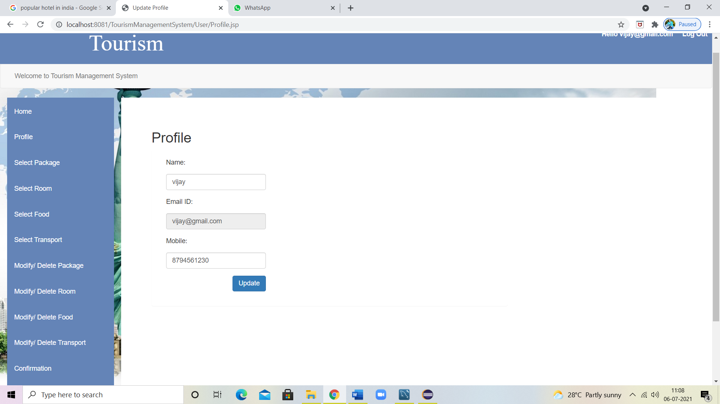

**Book Package:**

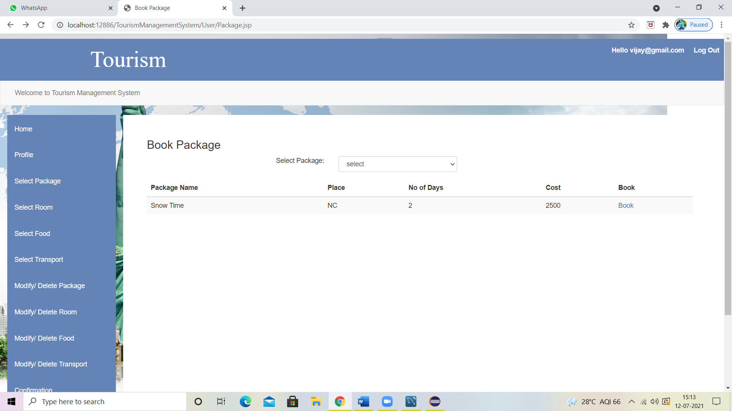

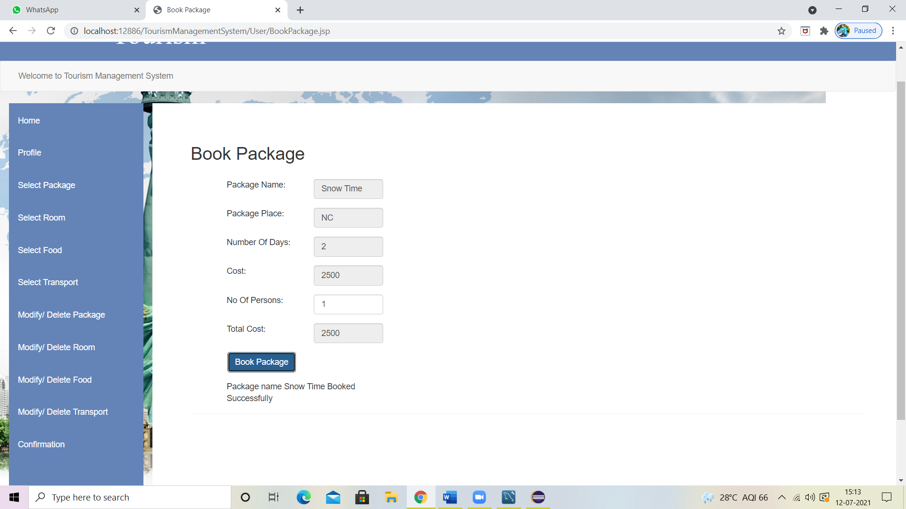

**Booking Room:**

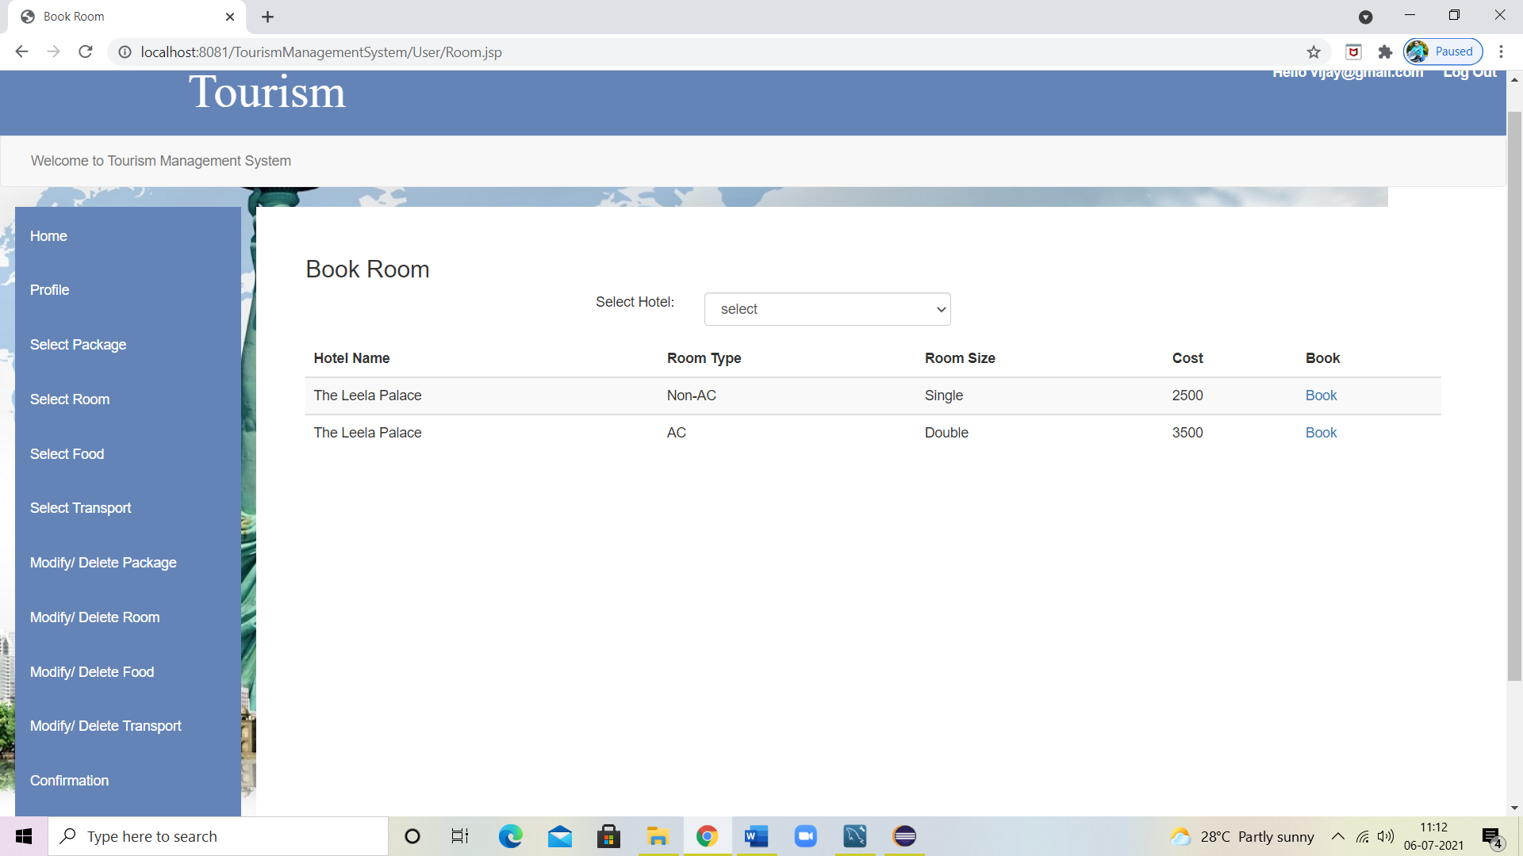

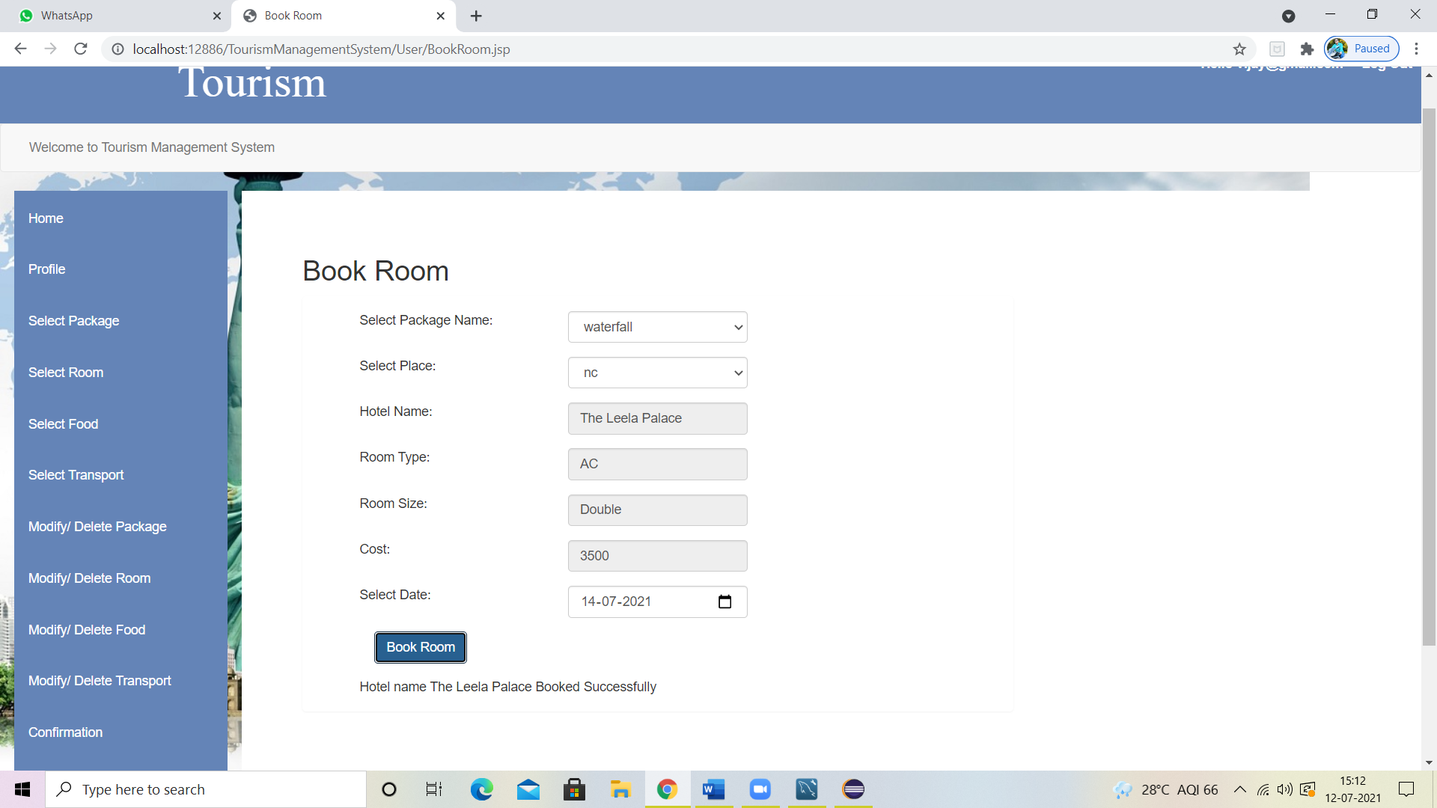

**Booking Food:**

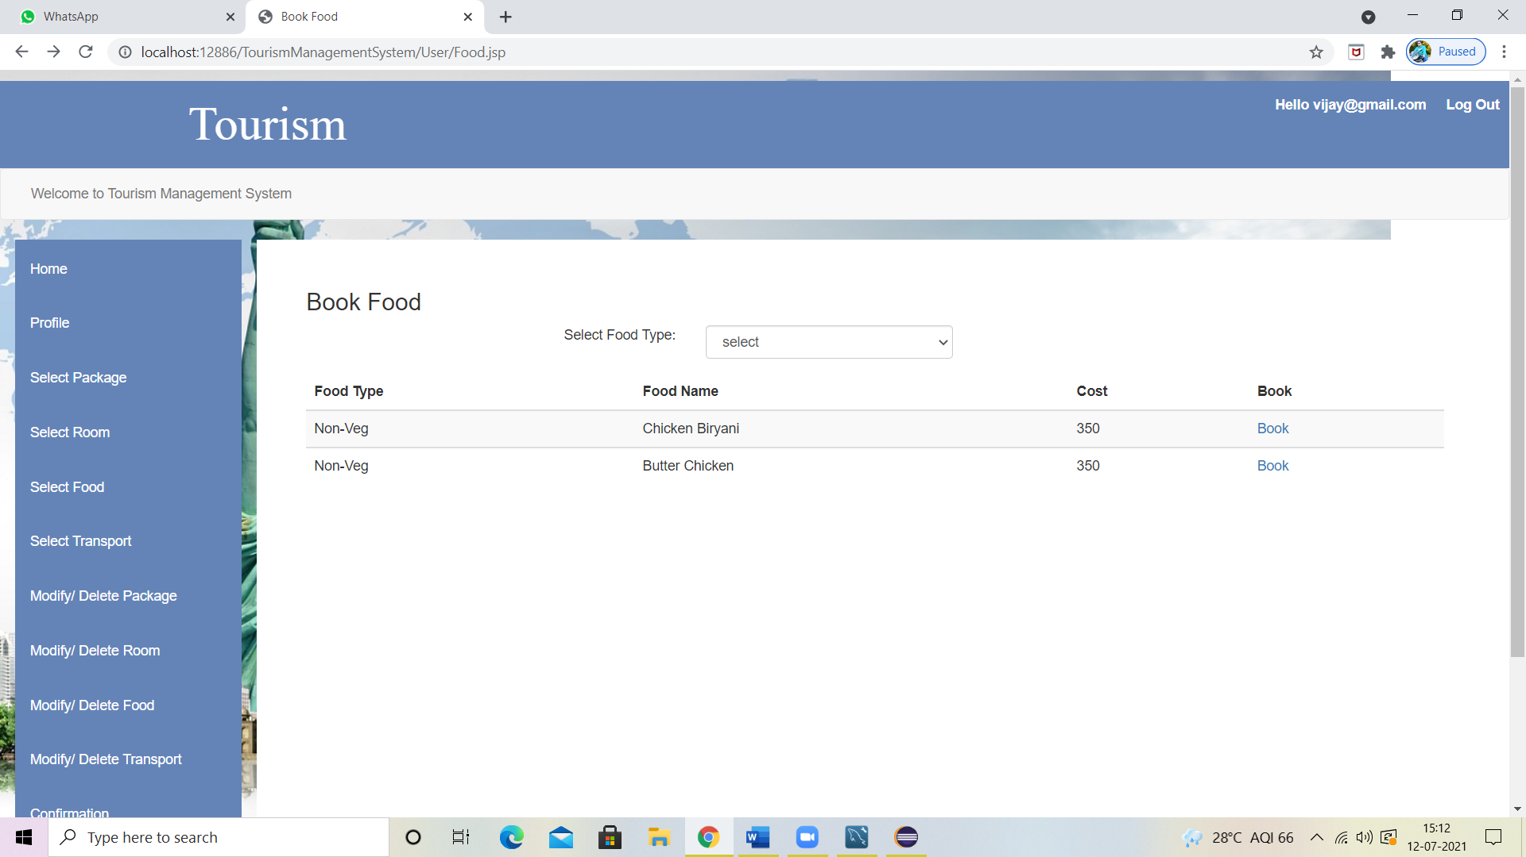

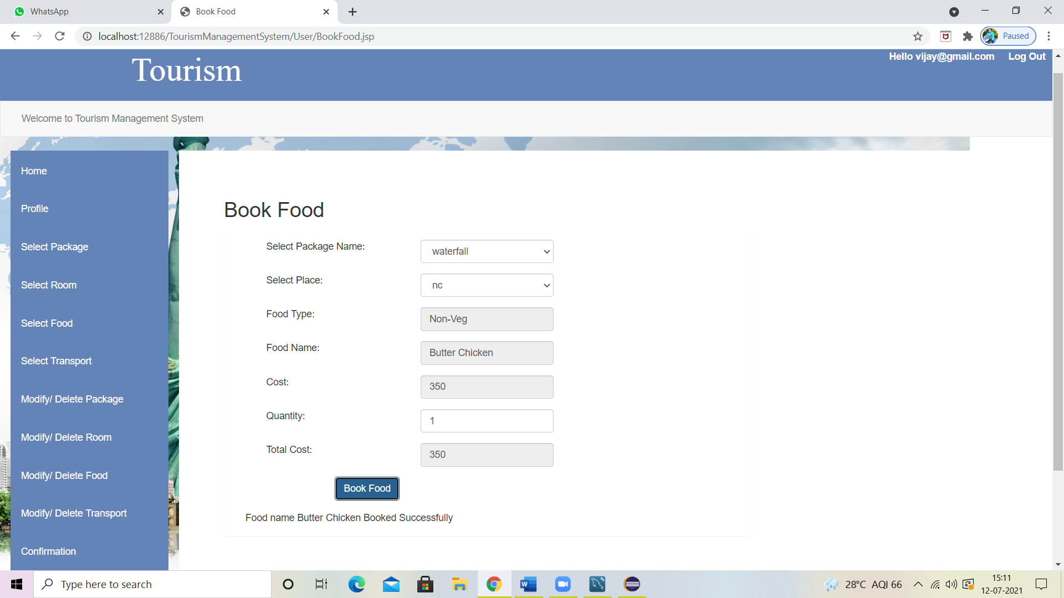

**Booking Transport:** 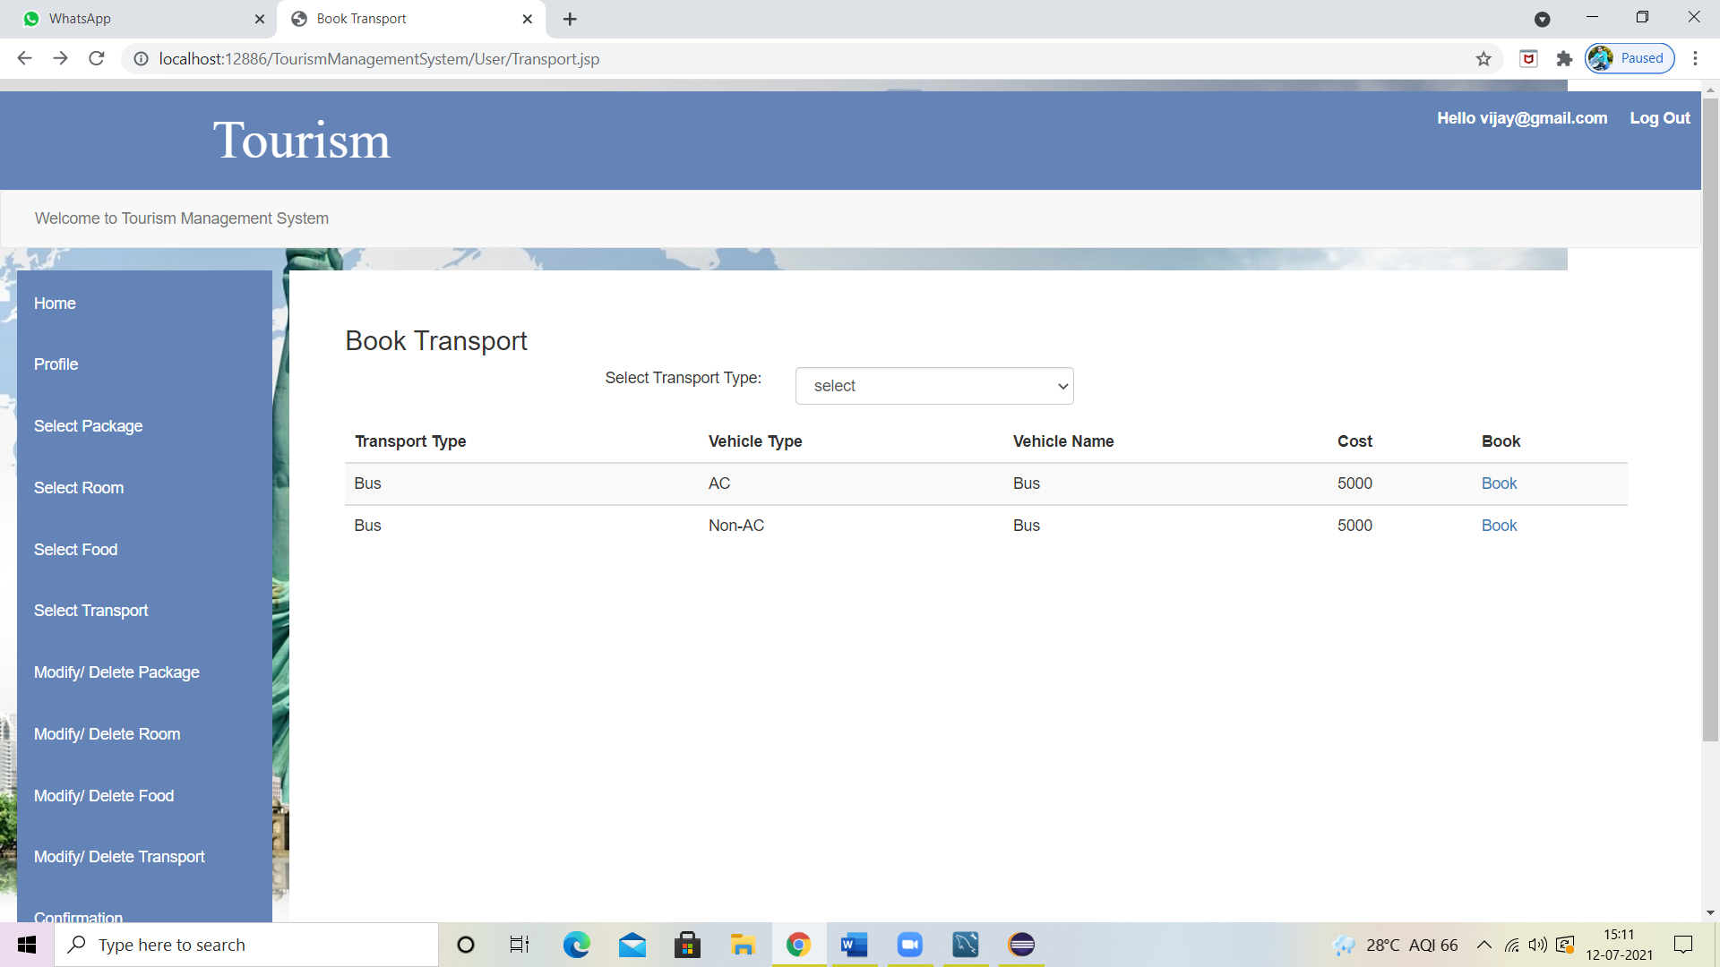

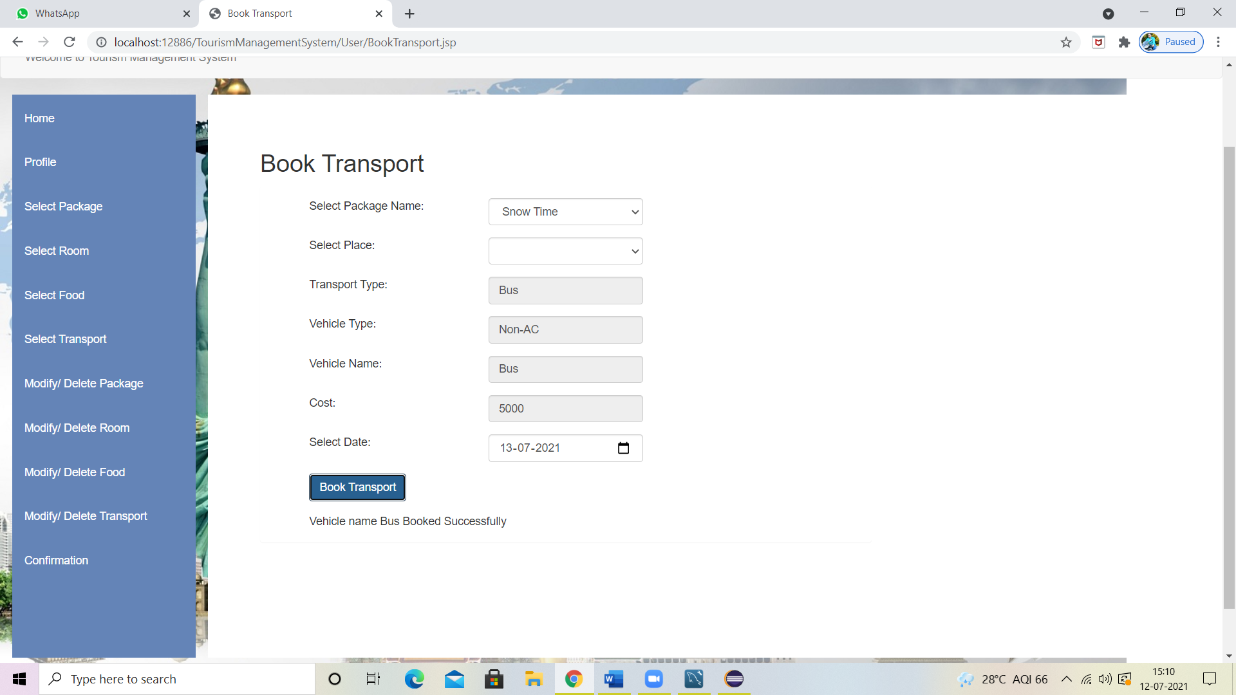

**Modify/Cancel Package:**

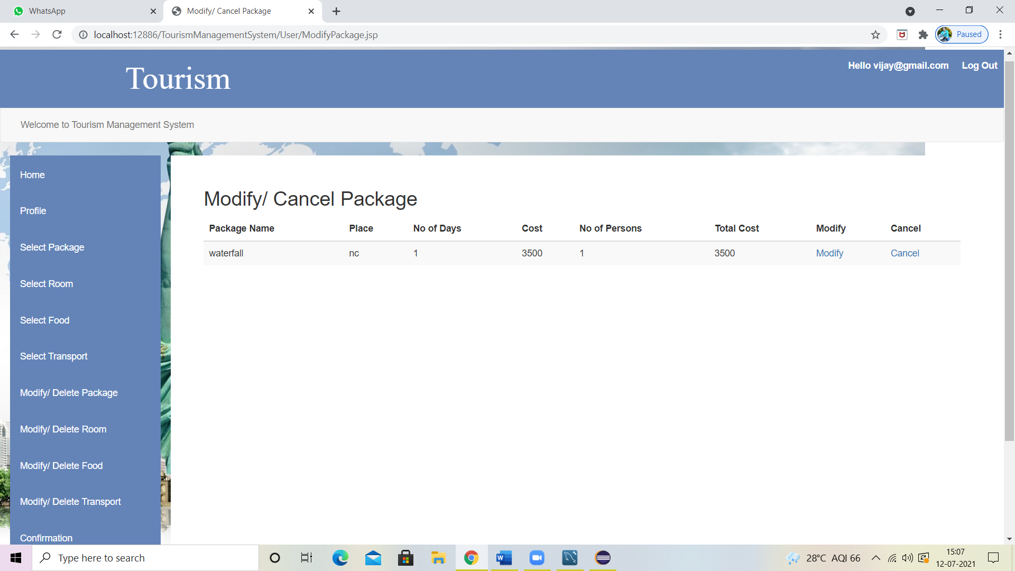

**Modify/Cancel Food:**

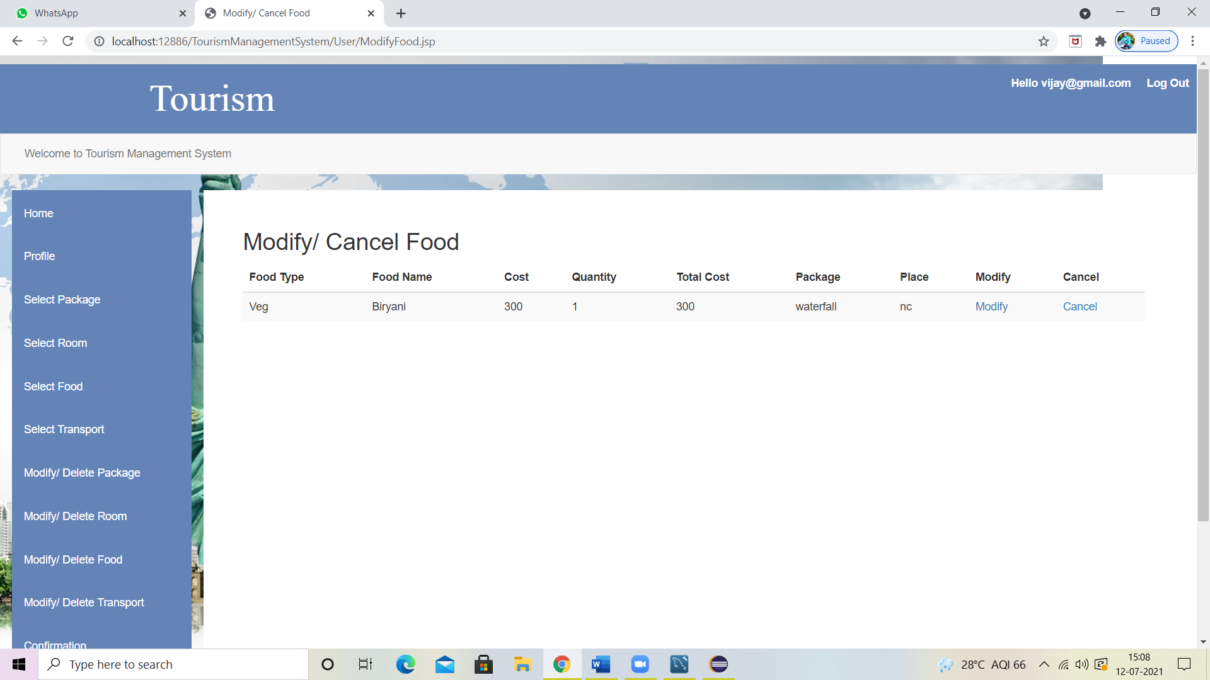

**Modify/Cancel Room:**

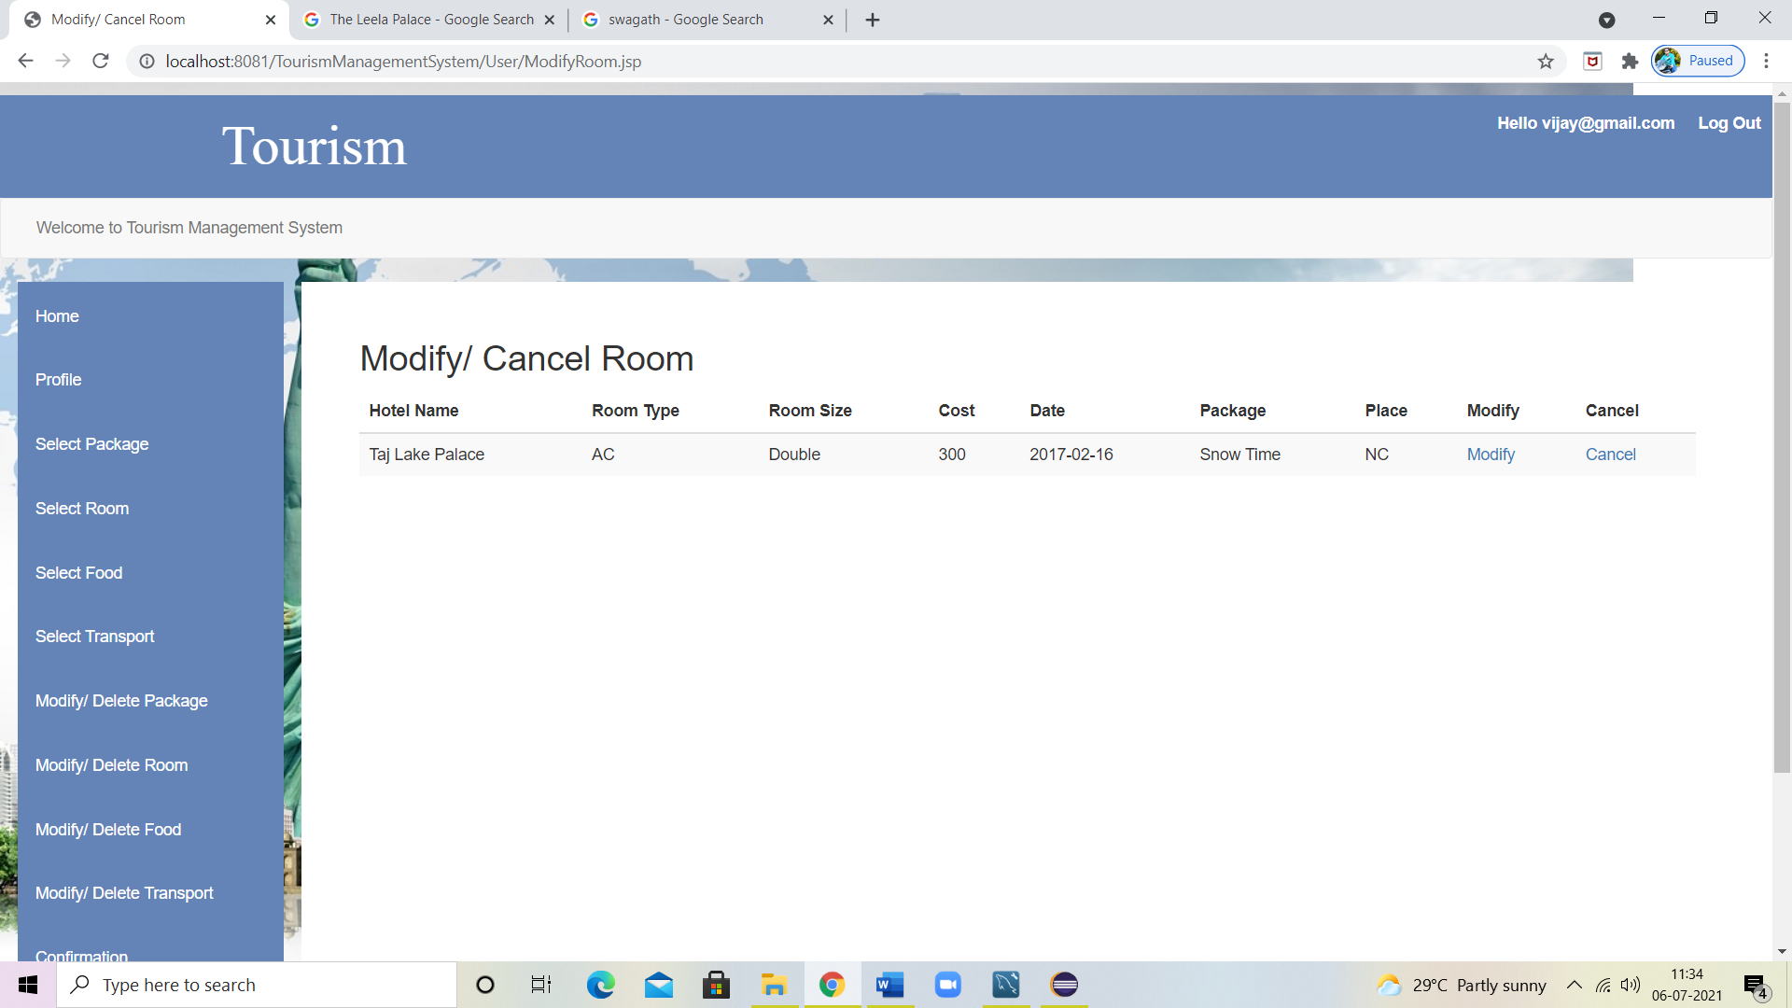

**Modify/Cancel Transport:**

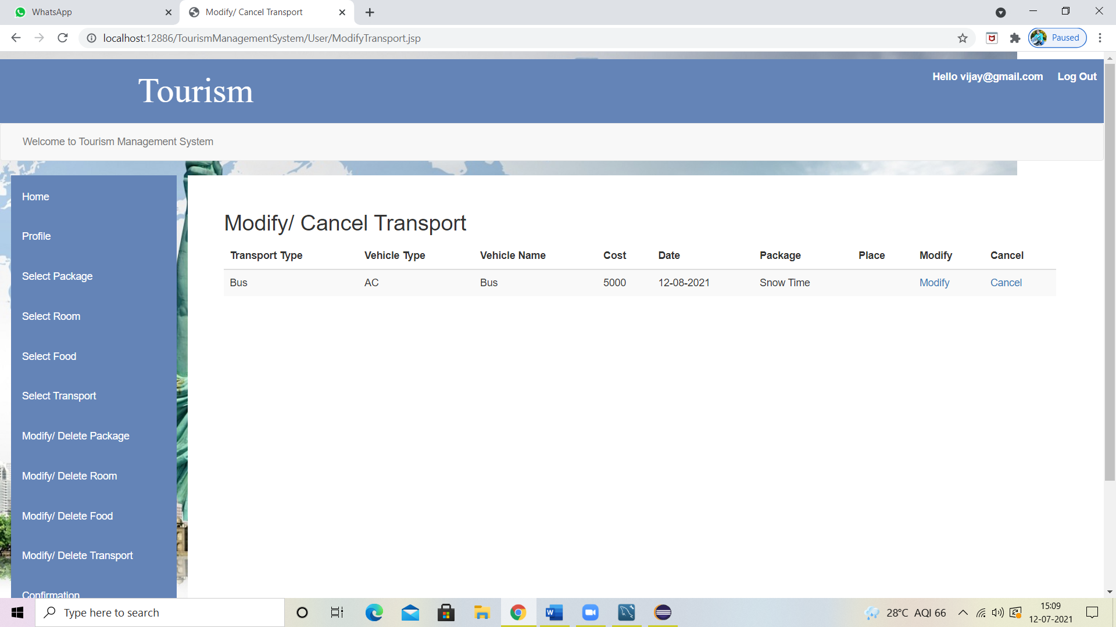

**Confirmation Details:**

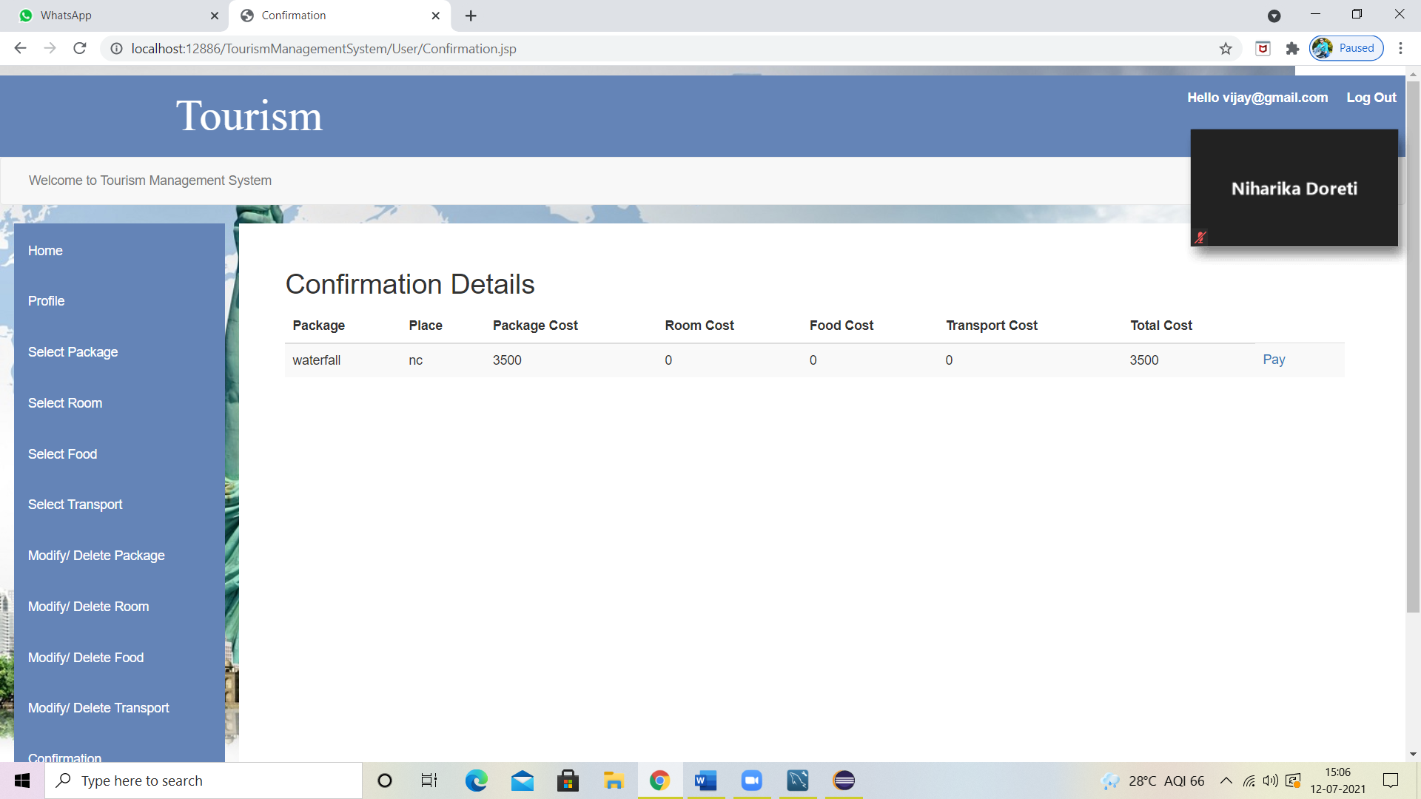

**Data Added in Database SuccessFully:**

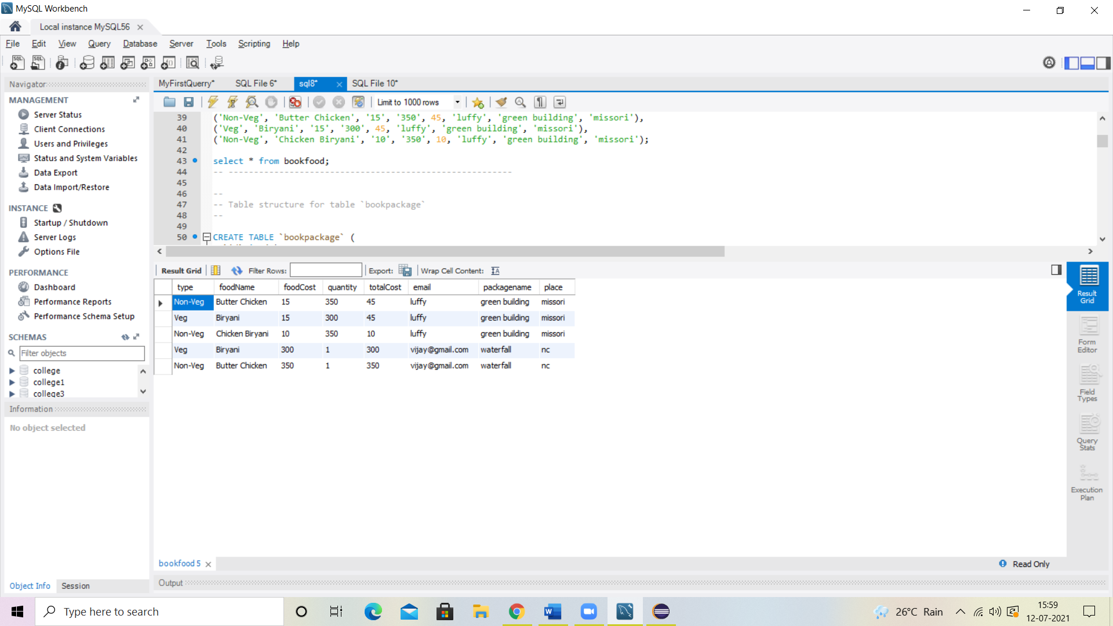

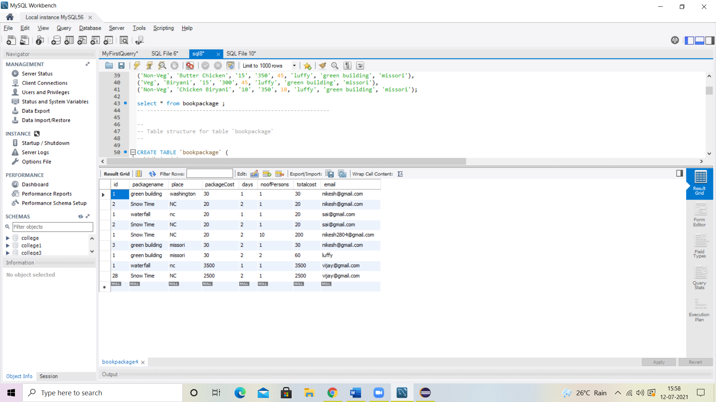

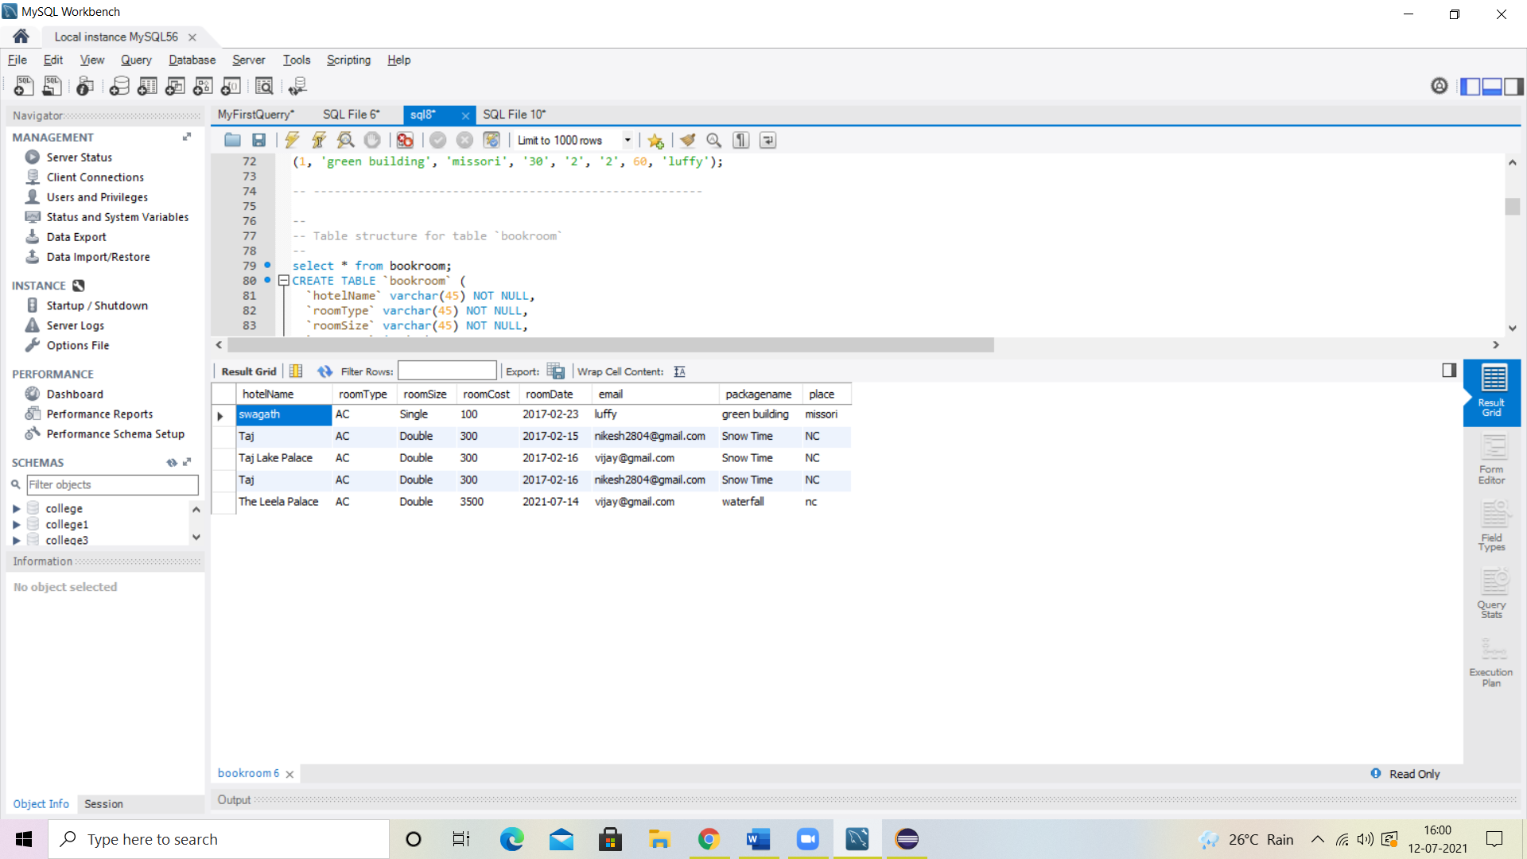

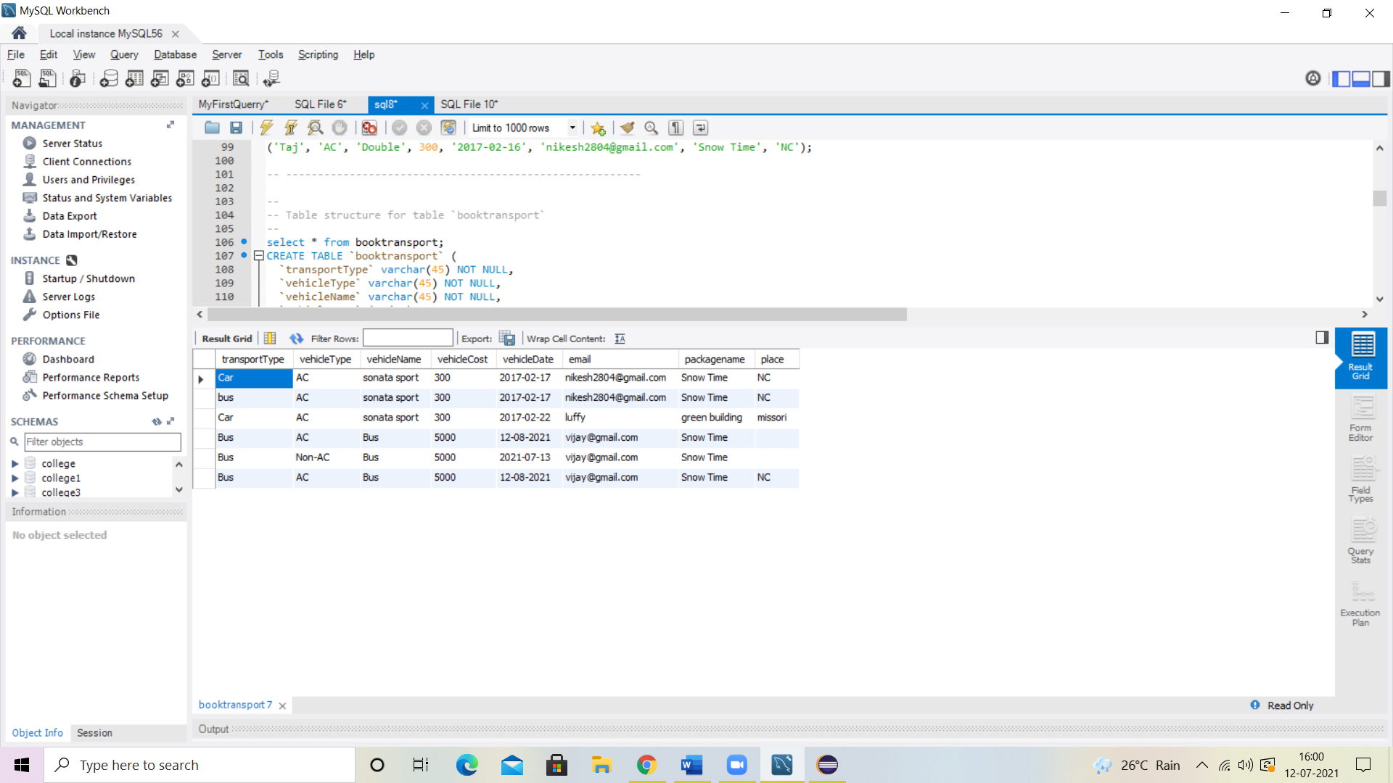

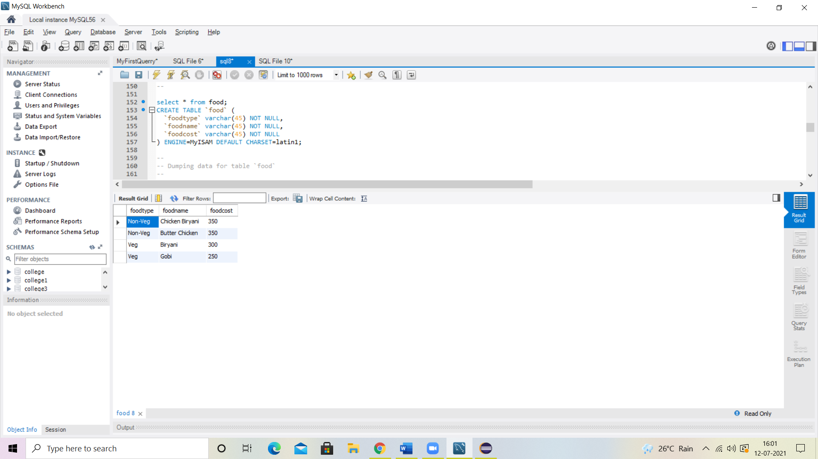

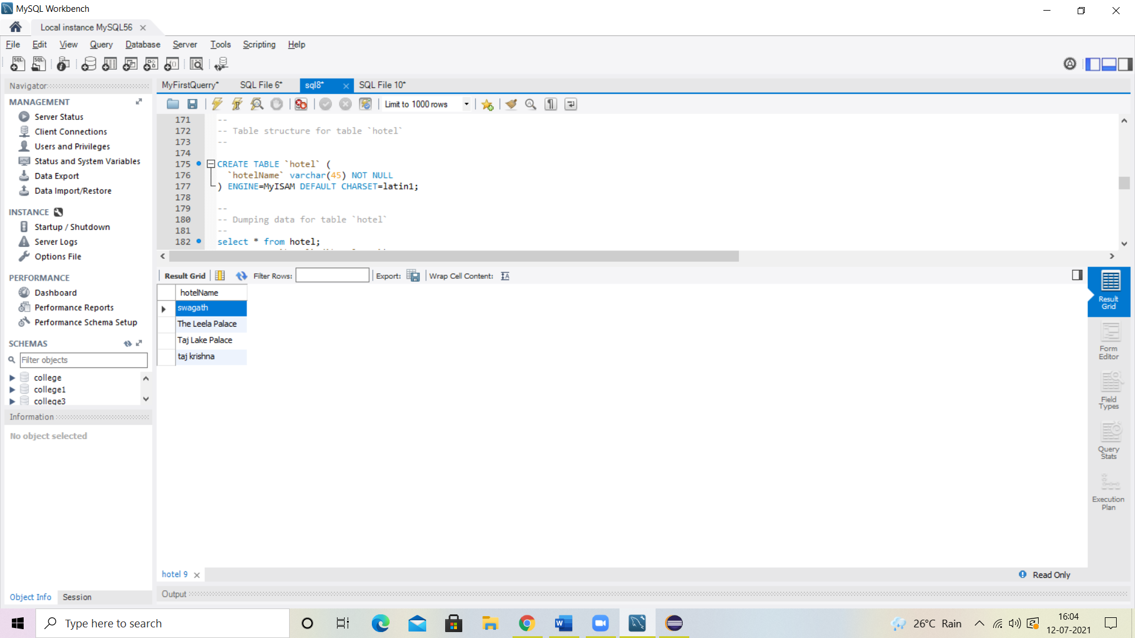

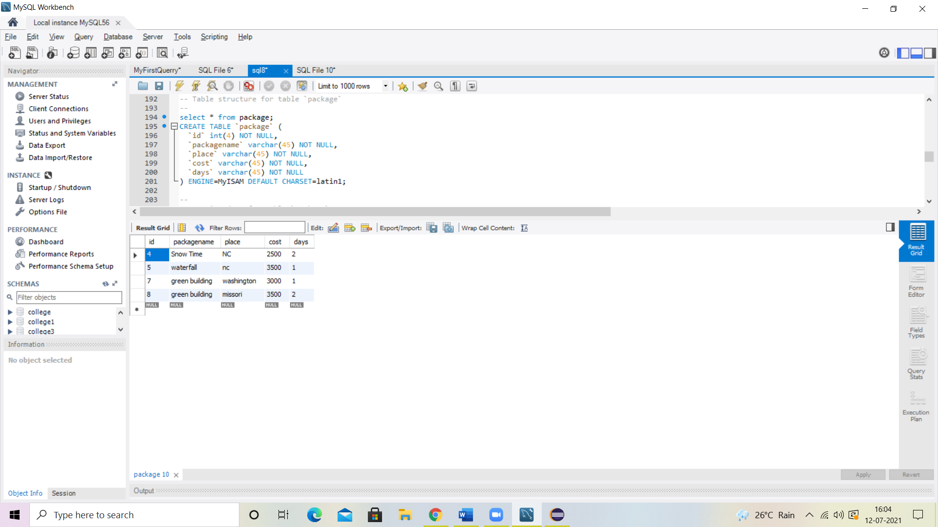

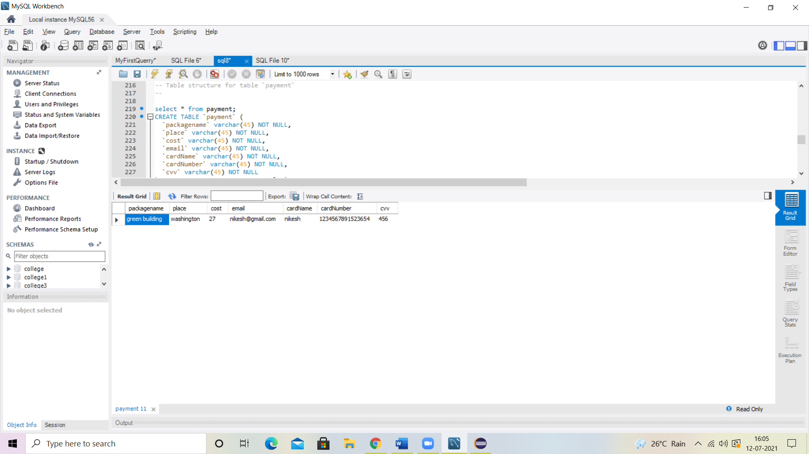

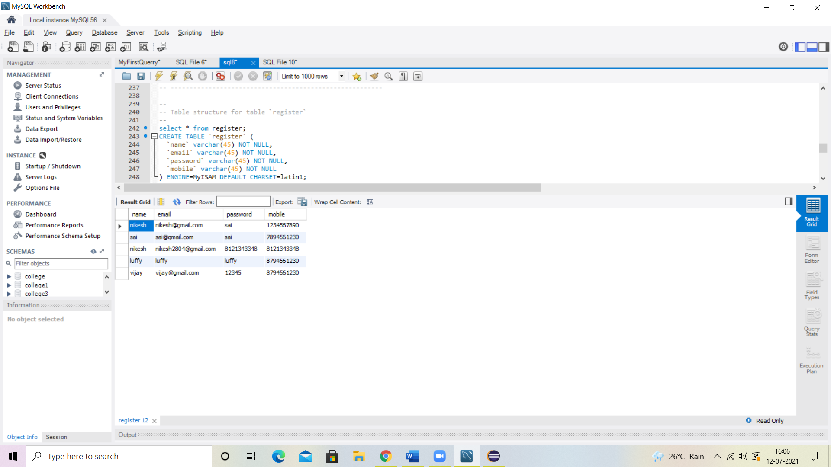

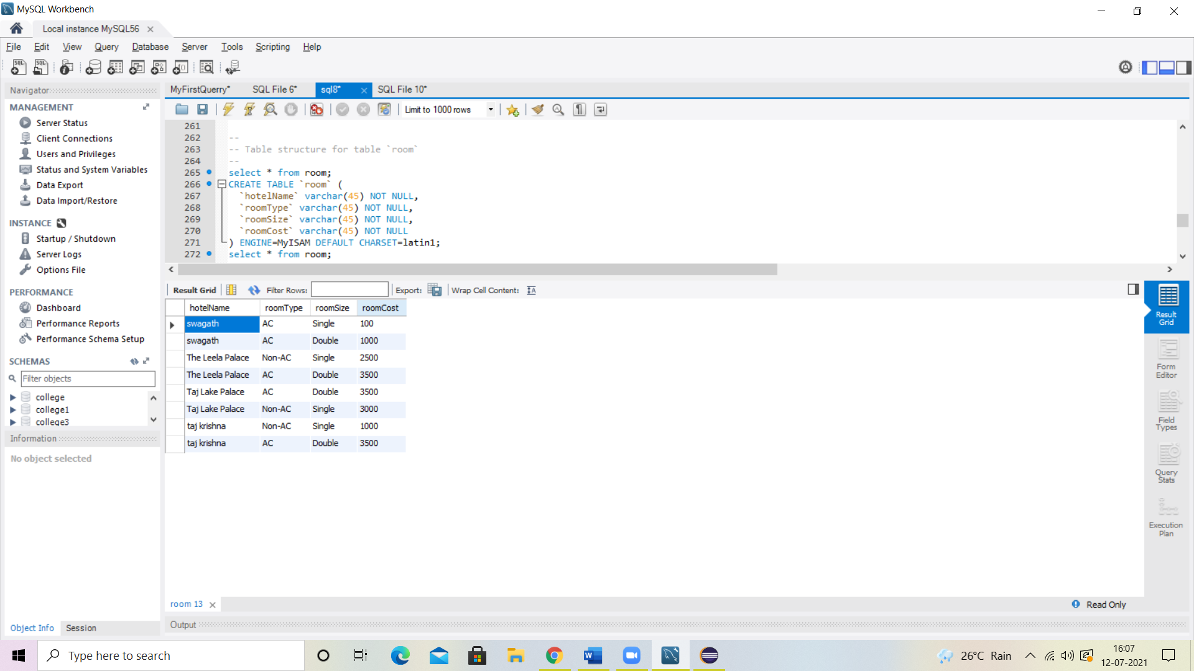

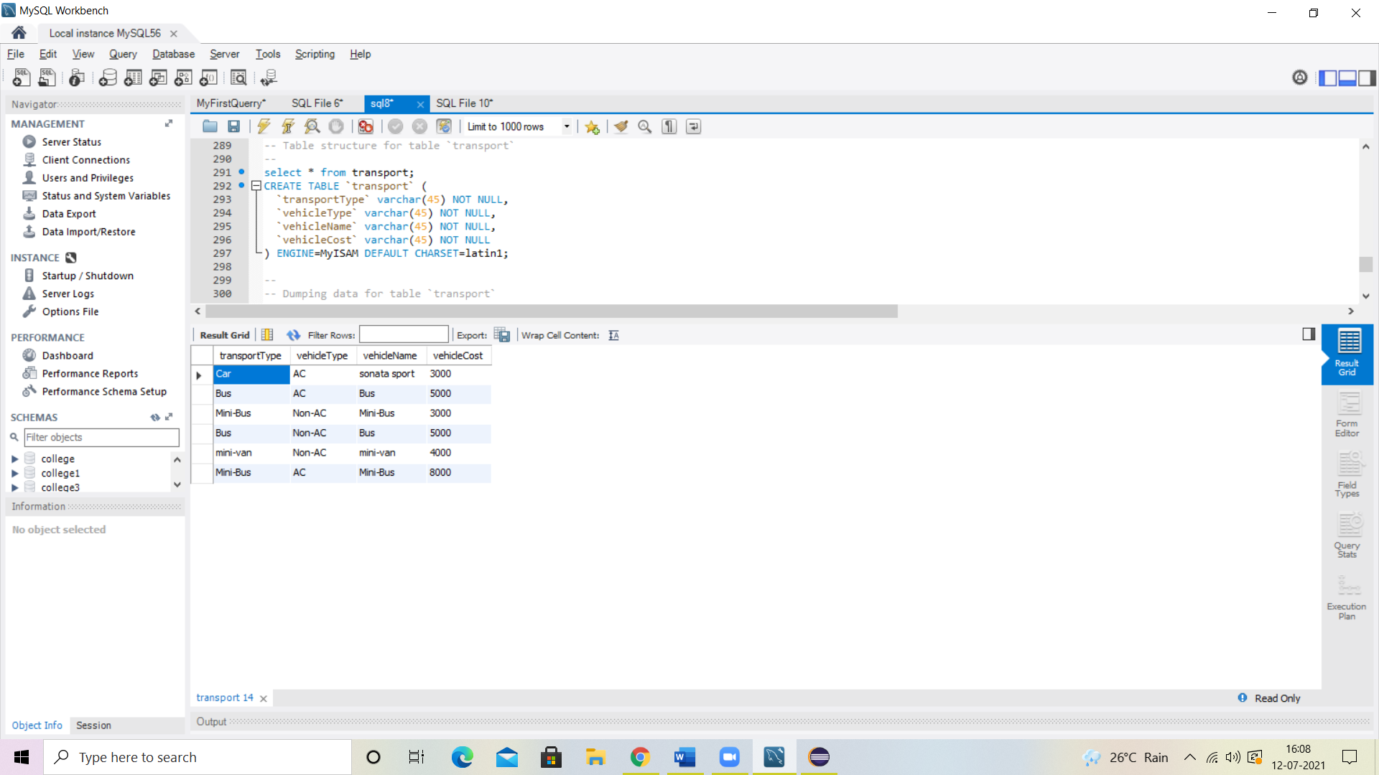

**Thank you**